Study Abroad Wish List

Spring 2020

Indholdsfortegnelse

[University of Washington 1](#_Toc23158720)

[University of Vermont 5](#_Toc23158721)

[High Point University 8](#_Toc23158722)

[University of Albany 11](#_Toc23158723)

[Buffalo State 14](#_Toc23158724)

[College at Brockport 16](#_Toc23158725)

[University of South Carolina 19](#_Toc23158726)

[University of Oklahoma 22](#_Toc23158727)

[University of misissipi 25](#_Toc23158728)

[UNIVERSITY OF MASSACHUSETTS BOSTON, UNITED STATES 27](#_Toc23158729)

[UNIVERSITY OF CALIFORNIA, SANTA CRUZ 31](#_Toc23158730)

[UC collection 32](#_Toc23158731)

[BEREKLY 33](#_Toc23158732)

[UCLA 39](#_Toc23158733)

[SAN DIEGO 42](#_Toc23158734)

[Merced 43](#_Toc23158735)

[MAUI STUFF 45](#_Toc23158736)

[MAUI NETWORK 45](#_Toc23158737)

**SITE FOR ECTS POINTS FROM AU:** [**https://studerende.au.dk/studier/fagportaler/biologi/udlandsophold/saadan-soeger-du/valg-af-kurser-og-forhaandsgodkendelse/forhaandsgodkendte-universiteter/**](https://studerende.au.dk/studier/fagportaler/biologi/udlandsophold/saadan-soeger-du/valg-af-kurser-og-forhaandsgodkendelse/forhaandsgodkendte-universiteter/)

# **University of Washington**

West Coast, Seattle, Washington State

12 credits per quarter as an undergraduate student – need 40:

<https://honors.uw.edu/studyabroaddocs/san_andres/docs/ects_credit_conversion.pdf>

US rank: 64 forbes

Autumn: late September – mid-December.   
Winter: 04. January – mid-March.   
Spring: 29. March – early June.   
Summer: not open for exchange students!

Skiing Resort is a 50min drive

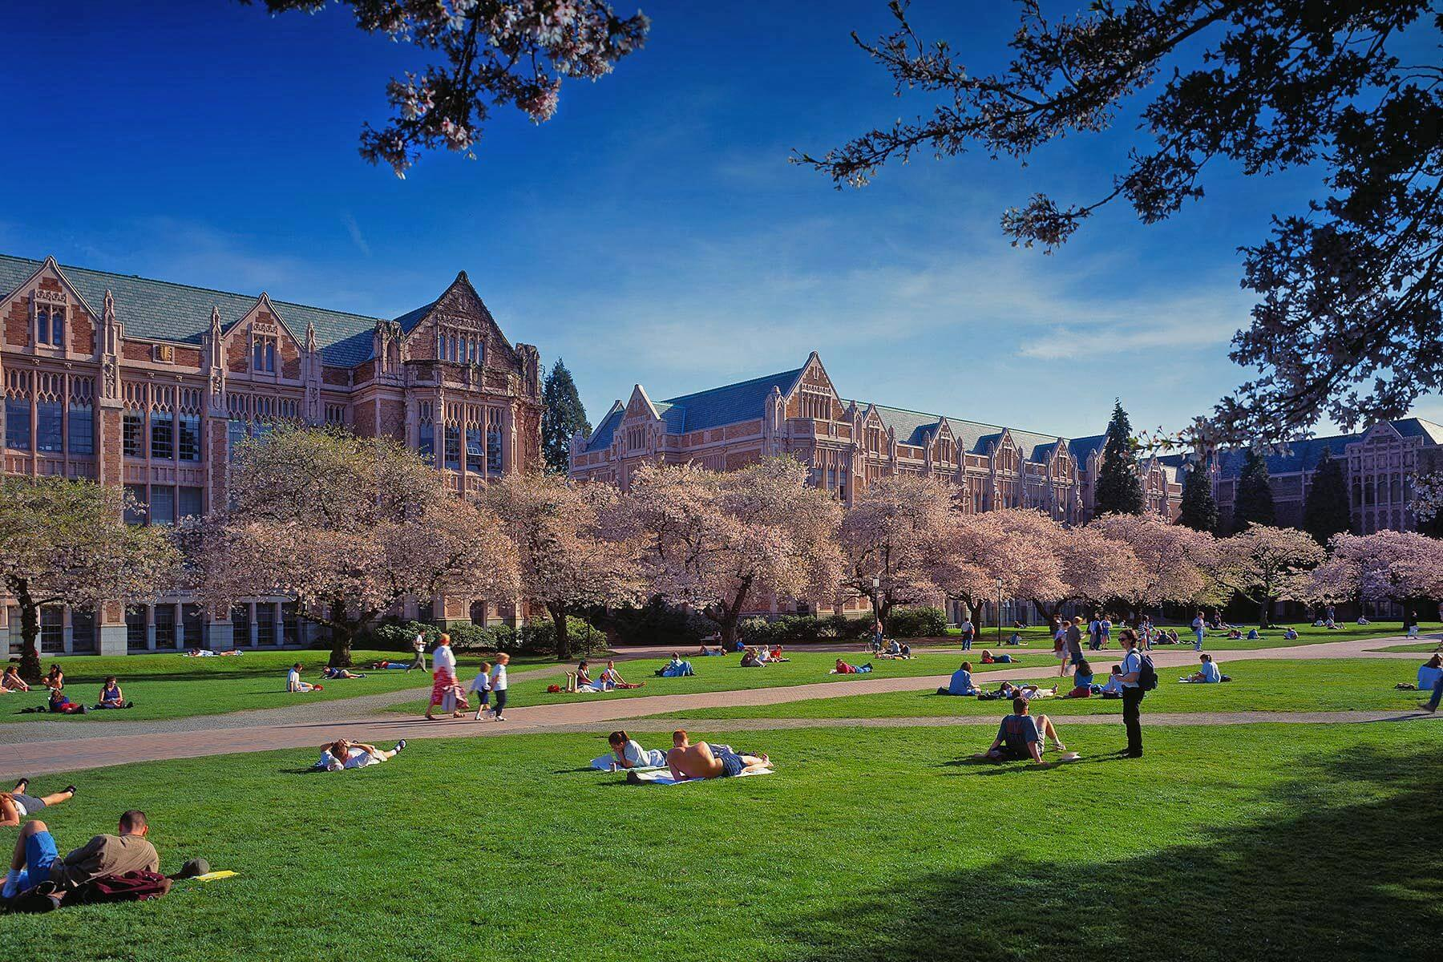

**NBIO 404 Neuropharmacology (3) NW**  
Actions of drugs on the brain at clinical, cellular, and molecular levels. Therapeutic use of drugs in treatment of neurological and psychiatric diseases. Abuse of drugs and the mechanisms of addiction, tolerance, and withdrawal. Prerequisite: NBIO 401. Instructors: Stella Offered: Sp.  
[View course details in MyPlan: NBIO 404](https://uwstudent.washington.edu/course/" \l "/courses/NBIO404" \t "_blank)

**NBIO 405 Neural Computation and Engineering Laboratory (3) NW***L. Johnson Dyhr*  
Introduces neural recording and quantitative analysis techniques to students with a background in quantitative methods. Prerequisite: Either AMATH 342, BIOL 162, or BIOL 220; and one of the following: MATH 308, AMATH 301, or AM

**NBIO 402 Diseases of the Nervous System (3) NW**  
Introduces the basic mechanisms of mammalian nervous system function through the study of human neurological diseases that result from specific disruption of neuronal signaling. Prerequisite: NBIO 401. Instructors: Froener, Horwitz Offered: W.  
[View course details in MyPlan: NBIO 402](https://uwstudent.washington.edu/course/" \l "/courses/NBIO402" \t "_blank)

**PSYCH 305 Abnormal Psychology (5) I&S**  
An overview of major categories of psychopathology, including description and classification, theoretical models, and recent research on etiology and treatment. Prerequisite: minimum 2.0 grade in PSYCH 202; 2.0 in PSYCH 209.  
[View course details in MyPlan: PSYCH 305](https://uwstudent.washington.edu/course/" \l "/courses/PSYCH305" \t "_blank)

**PSYCH 322 Introduction to Drugs and Behavior (3) NW**  
Basic concepts of drug action emphasizing the behavioral consequences of the intake of a variety of drugs. Prerequisite: PSYCH 202. Instructors: Diaz  
[View course details in MyPlan: PSYCH 322](https://uwstudent.washington.edu/course/" \l "/courses/PSYCH322" \t "_blank)

**POL S 212 Philosophy of Feminism (5) I&S, DIV**  
Philosophical analysis of the concepts and assumptions central to feminism. Theoretical positions within the feminist movement; view of the ideal society, goals and strategies of the movement, intersections of the sex-gender system with other systems of oppression. Offered: jointly with GWSS 206/PHIL 206.  
[View course details in MyPlan: POL S 212](https://uwstudent.washington.edu/course/" \l "/courses/POL S212" \t "_blank)

**DANISH 411 Danish for Professionals (3) VLPA**  
Combines intensive beginning Danish language for professionals with a substantive introduction to Danish culture and society. This course is geared to upper-division undergraduates and graduate students preparing to hold internships in professional offices in Denmark or study at Danish universities via UW study Abroad. Does not meet foreign language requirement. Offered: Sp.  
[View course details in MyPlan: DANISH 411](https://uwstudent.washington.edu/course/" \l "/courses/DANISH411" \t "_blank)

**DANISH 311 Topics in Danish Literature and Culture (5, max. 15) VLPA**  
Selected topics in modern Danish literature and culture, such as women's literature, Danish identity and the European Union, contemporary drama and film, or children's literature.  
[View course details in MyPlan: DANISH 311](https://uwstudent.washington.edu/course/" \l "/courses/DANISH311" \t "_blank)

**SPHSC 501 Neural Bases of Speech, Language, and Hearing (4)***Burns, Miller*  
Neuroanatomical and neurophysiological bases of language, hearing, sensory, and motor function. Special emphasis given to brain behavior correlates and behavioral consequences to speech, language, and hearing as a result of neurologic injury or disease. Offered: A.  
[View course details in MyPlan: SPHSC 501](https://uwstudent.washington.edu/course/" \l "/courses/SPHSC501" \t "_blank)

**CSE 415 Introduction to Artificial Intelligence (3) NW**  
Principles and programming techniques of artificial intelligence: LISP, symbol manipulation, knowledge representation, logical and probabilistic reasoning, learning, language understanding, vision, expert systems, and social issues. Intended for non-majors. Not open for credit to students who have completed CSE 473. Prerequisite: CSE 373.  
[View course details in MyPlan: CSE 415](https://uwstudent.washington.edu/course/" \l "/courses/CSE415" \t "_blank)

**CSE 416 Introduction to Machine Learning (4) NW**  
Provides practical introduction to machines learning. Modules include regression, classification, clustering, retrieval, recommender systems, and deep learning, with a focus on an intuitive understanding grounded in real-world applications. Intelligent applications are designed and used to make predictions on large, complex datasets. Prerequisite: CSE 143 or CSE 160; and STAT 311, STAT 390/MATH 390, or STAT 391 Offered: jointly with STAT 416.  
[View course details in MyPlan: CSE 416](https://uwstudent.washington.edu/course/" \l "/courses/CSE416" \t "_blank)

**CSE 446 Machine Learning (4)**  
Methods for designing systems that learn from data and improve with experience. Supervised learning and predictive modeling: decision trees, rule induction, nearest neighbors, Bayesian methods, neural networks, support vector machines, and model ensembles. Unsupervised learning and clustering. Prerequisite: CSE 332; either STAT 390, STAT 391, or CSE 312.  
[View course details in MyPlan: CSE 446](https://uwstudent.washington.edu/course/" \l "/courses/CSE446" \t "_blank)

**ASL 101 Elementary American Sign Language I (5)***L. Forshay, K. Winter*  
Introduction to American Sign Language using conversational methods. Covers vocabulary, grammatical usage, and culturally appropriate behavior within the deaf community. First in a sequence of three. Offered: A.  
[View course details in MyPlan: ASL 101](https://uwstudent.washington.edu/course/" \l "/courses/ASL101" \t "_blank)

**NEUSCI 301 Introduction To Cellular And Molecular Neuroscience (3, 5)**

Introduces students to the physiological and molecular properties of individual nerve cells and the synaptic connections between them, and to principles of nervous system development. Includes weekly laboratory sessions.

**Course Prerequisite**BIOL 220.

**NEUSCI 198 The Biology Of Human Consciousness (5)**

An overview of the basic physiology and anatomy of the human nervous system, then explore a series of topics where direct experiments have given us a view of the biological mechanisms that explain high-level brain functions - language, memory, object recognition, the attachment of emotion to people we know and the sensation of time.

**Course Prerequisite**None

**[PSYCH 489 Clinical Psychology (3)](https://myplan.uw.edu/course/#/courses/PSYCH%20489?id=9ec7ab96-dcb0-48f7-b3ff-5276415930c9)**

Basic issues, methods, and research: professional issues, psychological assessment, and approaches to psychotherapy and behavioral change.

Course Requisites: Minimum 2.0 grade in [PSYCH 305](https://myplan.uw.edu/student/myplan/plan?methodToCall=start&viewId=PlannedCourses-FormView&formKey=4297b22e-a1b3-4334-b3d1-43e54df62a88&cacheKey=2w1ww26rqiv3363u7vr447).

**PSYCH 305 Abnormal Psychology (5)**

An overview of major categories of psychopathology, including description and classification, theoretical models, and recent research on etiology and treatment.

Course Prerequisite Minimum 2.0 grade in PSYCH 202; 2.0 in PSYCH 209.

**NEUSCI 401 Systems Neuroscience (3)**

Introduces students to the anatomical and physiological organization of the major sensory, motor, and associative systems of the mammalian brain. Behavioral data used to stress functional integration of systems. Includes gross brain anatomy demonstration and computer tutorials. **Course Prerequisite**NEUSCI 301.

**NEUSCI 402 Diseases Of The Nervous System (3)**

Introduces the basic mechanisms of mammalian nervous system function through the study of human neurological diseases that result from specific disruption of neuronal signaling.

**Course Prerequisite NEUROSCI 401**

**NEUSCI 405 Neural Computation And Engineering Laboratory (3)**

Introduces neural recording and quantitative analysis techniques to students with a background in quantitative methods.

**Course Prerequisite**:Either AMATH 342, BIOL 162, or BIOL 220; and one of the following: MATH 308, AMATH 301, or AMATH 352.

NEURO 504 Biophysics Of Nerve, Muscle, And Synapse (3)

Introduces biophysical properties of nerve and muscle cells. Topics include intrinsic electrical properties of neurons, ion channels, receptor signaling, calcium signaling, contraction of muscles, and synaptic function. Instructors: Sullivan

**Course Prerequisite**: none

NEURO 502 Introduction To Neurobiology (5)

Systems level survey of vertebrate system, focusing on sensory system, on motor system, and on neuroanatomy. Lectures cover topics in sensory and motor systems. Laboratory includes brain dissection and study of intact, prosected, and sectioned brain and spinal cord. Emphasis is on human nervous system. Instructors: Sherk

**Course Prerequisite**: none

# **University of Vermont**

Burlington has a population of 40,000,

Close to the ocean

1 ECTS=0.5 UVM

All above 300 is graduate level

Rank: #121

Start: jan 19

<https://www.uvm.edu/registrar/uvm-academic-calendar-2020-2021>

Rating: <https://www.forbes.com/colleges/university-of-vermont/#f4dd2c04de2c>

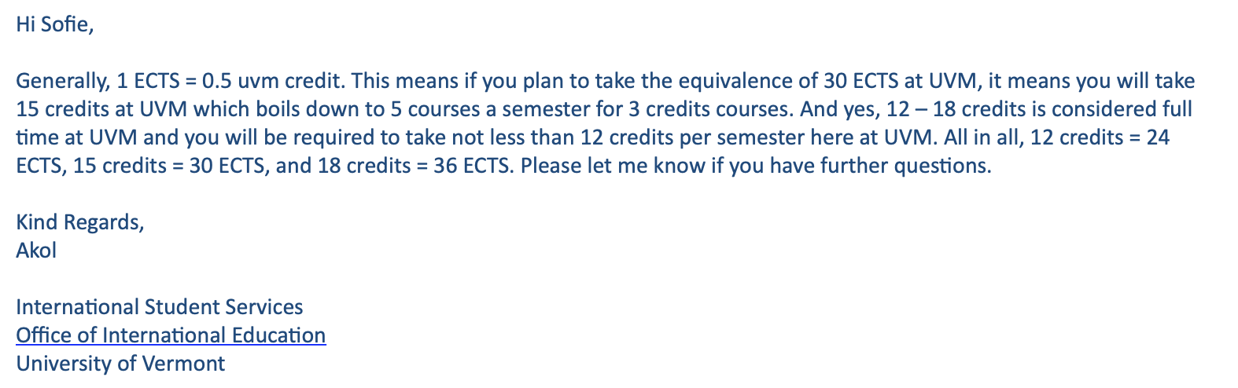

12-18 credit hours per semester. Most students at UVM take 15 per semester.

Exchange students are unlikely to be able to enroll in any Theater or Art/Art Studio courses. Courses in psychology are also limited,

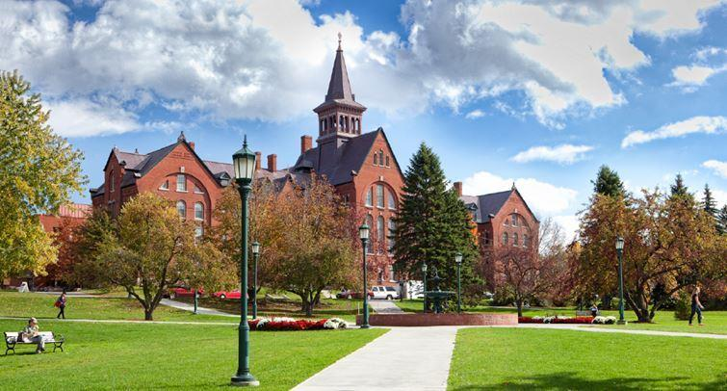

**NSCI 111. Exploring Neuroscience. 3 Credits.**

In-depth survey of neuroscience topics, including neuron function, the anatomical and functional organization of the nervous system, and diseases of the nervous system.

Prerequisites: PSYS 001; CHEM 023 or CHEM 031; and one of the following pairs of courses: BIOL 001 and BIOL 002, BCOR 011 and BCOR 012, or ANPS 019 and ANPS 020.

**NSCI 112. Exploring Neurosci Laboratory. 1 Credit.**

Laboratory course in neuroscience designed to provide hands-on experience with methods of inquiry in neuroscience. Goals of this course include the development of problem-solving skills, data analysis, the scientific method, and science communication. Neuroscience majors only. Prerequisites: PSYS 001; CHEM 023 or CHEM 031; and one of the following pairs of courses: BIOL 001 and BIOL 002, BCOR 011 and BCOR 012, or ANPS 019 and ANPS 020.

**NSCI 222. Cellular Neurophysiology. 3 Credits.**

Fundamentals of cellular neurophysiology through lecture, independent student reading and faculty-led group discussions of journal articles. Prerequisites: NSCI 110 or, NSCI 111 and NSCI 112, or Instructor Permission.

**NSCI 225. Human Neuroanatomy. 0 or 3 Credits.**

Functional anatomy of the human nervous system and its cells. Focus on both peripheral and central nervous system. Lectures and laboratory (gross and microscopic anatomy). Prerequisite: Instructor permission.

**NSCI 230. Comparative Neurobiology. 3 Credits.**

Examination of the cellular mechanisms that underlie selective motor and sensory abilities, and unique behaviors that have evolved in various species. Discussion and student presentations. Prerequisite: ASCI 141 or BIOL 106 or NSCI 111 or PSYS 115 or Instructor permission.

**NSCI 255. Neuroregeneration. 3 Credits.**

An analysis of the cellular and molecular processes involved in injury, responses to damage, and differences in the capacity of specific neural tissues to regenerate. Prerequisite: NSCI 111.

**NSCI 261. Neurobiology. 3 Credits.**

Focus on molecular and cellular aspects of the nervous system. Electrical signaling, synaptic transmission, signal transduction, neural development, plasticity, and diseases. Prerequisites: BIOL 103 or ANPS 019 & ANPS 020.

**NSCI 270. Diseases of the Nervous System. 3 Credits.**

Senior level, seminar-style capstone course in which students bring together information learned in other courses for an in-depth study of disease states of the nervous system. Pre/co-requisites: NSCI 110 and Senior standing.

**NSCI 280. Glia: Not Just Neuron Glue!. 3 Credits.**

Interdisciplinary course in which students engage in a focused, indepth exploration of how glial cells contribute to neurological and psychiatric disorders. Prerequisites: NSCI 111; Course director approval. Pre/Co-requisites: NSCI 111; Course Director permission.

**NSCI 300. Intro Functional Neuroimaging. 3 Credits.**

Functional neuroimaging may be the most exciting recent development in cognitive neuroscience. Students will learn about neuroimaging, and work in small groups to develop experiments, acquire and analyze functional MRI data an MRI scanner.

**NSCI 302. Neuroscience. 3 Credits.**

Functional anatomy of the human nervous system. Lectures and laboratory providing learning experience with dissected specimens, gross and microscopic anatomy. Incorporates clinical information from physician-scientists. Prerequisite: Physical Therapy major or Instructor permission.

**NSCI 306. Techniques in Neurobiology. 3 Credits.**

Discussion of techniques used to study the nervous system. Experience with light, fluorescence, electron microscopy; microsurgical procedures; electrophysiological stimulating, recording techniques; neuronal tracing techniques. Prerequisite: Permission of the Instructor.

**NSCI 323. Neurochemistry. 3 Credits.**

Biochemistry of the nervous system. Topics include ion channels, synaptic function, neurotransmitters and neuropeptides, signal transduction, and hormones in brain function. Prerequisite: Permission of the Instructor.

**PSYS 170. Abnormal Psychology. 3 Credits.**

Describing and defining abnormal behavior; models of etiology; research evidence for biological and social models; methods of intervention and prevention. Prerequisite: PSYS 001.

**PSYS 115. Biopsychology. 3 Credits.**

Biological bases of behavior: classical and contemporary issues, including introduction to nervous system, behavioral effects of drugs, chemical bases of behavioral disorders. Prerequisites: PSYS 001 or BIOL 001.

**PSYS 214. Adv Cognitive Neuroscience. 3 Credits.**

Cognitive Neuroscience studies thinking processes (e.g., attention, memory, problem solving) by investigating brain function. Focuses on dominant theories and relevant empirical data including a focus on non-invasive brain imaging of humans. Prerequisites: PSYS 053; PSYS 111 or PSYS 115 or NSCI 111.

**PSYS 216. Psychopharmacology. 3 Credits.**

Effects of drugs (both medical and recreational) on behavior. Topics such as drug effects on learning, memory, motivation, perception, emotions, and aggression. Prerequisites: PSYS 053; PSYS 115 or NSCI 111.

# **High Point University**

12 credits (3 4-credit classes) and maximum 18 credits per semester. However, most students take 4 classes worth 4 credits each (recommended number of credits for exchange students is 16 credits per term).

Courses are generally numbered according to academic credits: 1000-level courses are freshmen courses; 2000-level for sophomores; 3000-level for juniors; 4000-level for seniors.

Winston-Salem, North Carolina

Start: jan 10

Forbes #428: [https://www.forbes.com/colleges/high-point-university/#1c9db2ae3394](https://www.forbes.com/colleges/high-point-university/" \l "1c9db2ae3394)

Die coolen Psychology kurse scheint es nu rim Herbst zu geben

Auf deren Webseite muss man 8 Kurswünsche angeben

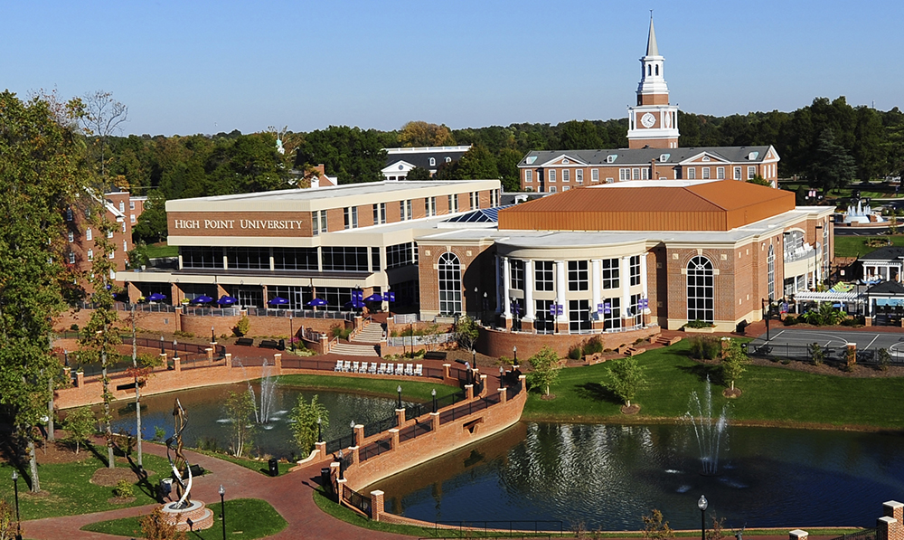

BIO 4250 **Journal Club: Advanced Topics in Neuroscience** (2 credits)

This is a capstone course with a flexible topic, dependent upon the expertise and interest of the professor. The course will include both written and oral presentation components, as well as discussion and critical analysis of primary literature.

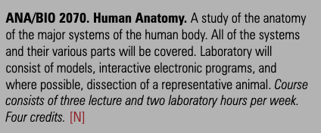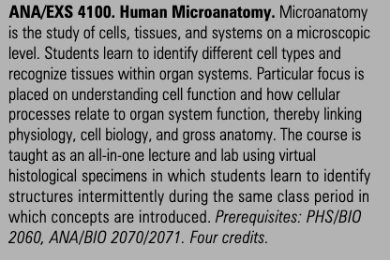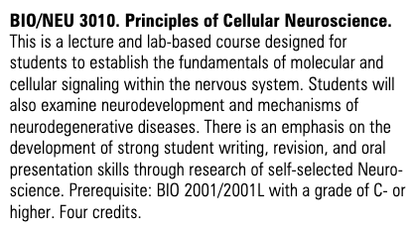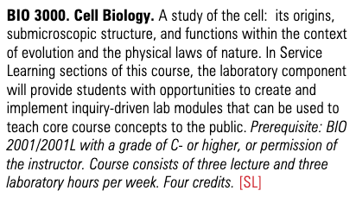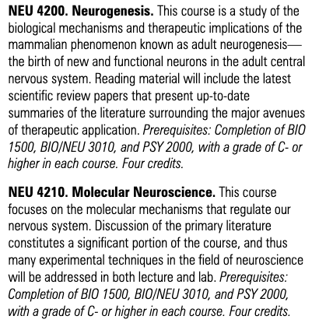

# **University of Albany**

State of New York

Plenty of skiing resorts close to Albany, 3 hours to the Canadian border, less than 4 hours to Montreal

Spring semester: ~22 January to mid-May

Ranked #147 (not forbes)

12 credits minimum/19 credits maximum

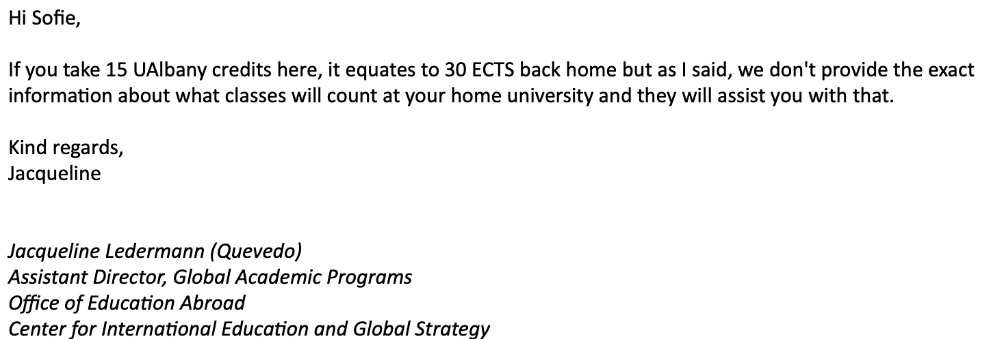

**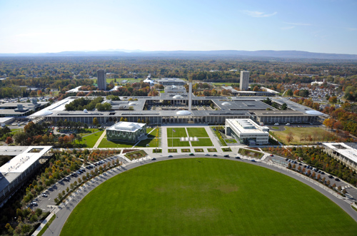**

**A PSY 214/214T Introduction to Biopsychology and Behavioral Neuroscience (3)**

An introduction to basic nervous system function and its control of behavior. Examination of the contribution of the field of neuroscience to understanding both normal and abnormal behavior. Topics will include anatomical, neurochemical, physiological, developmental, and endocrine aspects of neurobehavioral function. Only one version of A PSY 214 may be taken for credit. Prerequisite(s): A PSY 101.

**A PSY 314/314T Advanced Biopsychology and Behavioral Neuroscience (3)**

The role of physiological mechanisms in behavioral processes. Detailed examination of the involvement of biological systems in feeding and drinking, sexual behavior, sleep and arousal, learning and memory, psychopathology and psychopharmacology. Only one version of A PSY 314 may be taken for credit. Prerequisite(s): A PSY 214 or permission of instructor.

**A PSY 338/338T Abnormal Psychology (3)**

Survey of the behavior disorders, including the psychoses, psychoneuroses, mental deficiencies, and other forms of psychopathology. Only one version of A PSY 338 may be taken for credit. Prerequisite(s): A PSY 101, and 203 or 327.

**A PSY 388 Introduction to Psychopharmacology (3)**

Overview of the principles of psycho-pharmacology as relevant to drug use; the biological, neurochemical and physiological mechanisms underlying the actions of drugs; psychiatric medications and their therapeutic actions and associated toxicities; and the history, consequences, and complexity of drug use and abuse. Prerequisite(s): A PSY 214.

**A PSY 490 (= A BIO 490) Topics in Neuroscience (3)**

This course is designed as the capstone course for the interdisciplinary Neuroscience Minor. It is expected that Minors will take this course in the fall of their senior year. This course will be team taught by Neuroscience faculty from Biology and Psychology and will cover current topics in neuroscience research, engaging students in the original research literature and providing information about graduate education and careers in neuroscience. Prerequisite(s): Neuroscience minor, senior status, A PSY 314, and A BIO 341.

**A BIO 130 (formerly A BIO 121) General Biology: Molecular and Cell Biology and Genetics (3)**

Formerly A BIO 121. First course in a two semester sequence which offers a comprehensive survey of the structures and functions common to all living systems at the molecular, cellular, organismal, and population levels. This course emphasizes molecular and cell biology, and genetics. May not be taken for credit by students who have credit for A BIO 111 or A BIO 121.

**T BIO 260 Neural Basis of Behavior (3)**

An analysis of the neural basis of innate and learned behaviors, as well as the neurological deficits accompanying lesions of different parts of the brain. Emphasis will be placed on sensory processing, reflexive behavior, feature extraction and behavioral triggers, using simple learned behaviors amenable to analysis at the neuronal level, including analysis of membrane electrical activity, chemical synaptic activity and neuromodulation. Feature extraction will be considered as the basis of visual localization and prey (insect) capture in toads and in echo localization and insect capture in bats. Analysis of brain lesions will include both behavior and simultaneous brain imaging to connect the deficits with specific brain regions, and will cover semantic/episodic learning and amnesia, as well as speech/language comprehension. We will also discuss prospects for transplanting brain stem cells to cure diseases caused by cell death of specific neurons. T BIO 260 is the Honors College version of A BIO 460. Only one can be taken for credit. Neuroscience minors can take only one of T BIO 260 and T PSY 214 for credit toward the minor requirements. Open to Honors College students only. Prerequisite(s): A BIO 130 or 121, A BIO 131 or 120. May not be offered in 2019-2020.

**A BIO 341 Neurobiology (3)**The structure and function of the nervous system examined at the cellular level. Topics include: organization of nervous systems; morphology and physiology of nerve cells; synaptic transmission; sensory processing; cellular circuitry underlying "simple" behaviors; cellular basis of learning; and the development of neuronal connections. Prerequisite(s): A BIO 130 or 121, A BIO 131 or 120.

**A BIO 342 Neurophysiology Laboratory (2)** This laboratory course uses both neurophysiological techniques and computer simulations to examine the electrophysiological properties of the nervous system. The course covers the basic principles underlying action potentials, synaptic potentials and receptor potentials. These electrical signals are recorded from the nervous systems of cockroaches, crayfish and fruit flies; the signals are examined using data acquisition and analysis software. In subsequent exercises, a more detailed analysis of action potentials and synaptic potentials is performed using computer simulations. Prerequisite(s): A BIO 201, A BIO 202Z, and A BIO 341. Course fee applies. Consult the Schedule of Classes.

**A BIO 441 Molecular Neurobiology (3)**

The molecular biology of learning, memory, neural development and neurological disease. The course will relate the structure and function of receptors, second messengers, cytoskeletal proteins, transcription factors and gene structure to their roles in the nervous system. Prerequisite(s): A BIO 365 and either A BIO 341 or A BIO 217.

# **Buffalo State**

**New York State**

260,000 residents.

12 credits equivalent to four courses per semester

Spring semester: 21 jan - mid-May

ECTS????

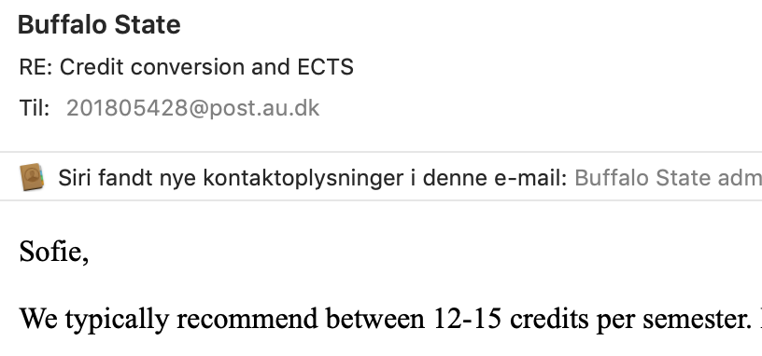

#196: <https://www.forbes.com/colleges/university-at-buffalo/#58a13fc42355>

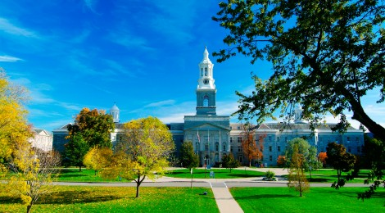

PSY 333 BRAIN AND BEHAVIOR

3, 3/0

Prerequisites: [PSY 101](http://ecatalog.buffalostate.edu/search/?P=PSY%20101), Grade of C or better. An introduction to the brain structures and processes that underlie cognition, emotion, and action. Topics include: general principles of behavioral neuroscience; neural, genetic, and epigenetic basis of behavior; functional brain anatomy; effect of drugs and hormones on brain and behavior. Offered every semester.

PSY 376 HEALTH PSYCHOLOGY

3, 3/0

Prerequisite: [PSY 101](http://ecatalog.buffalostate.edu/search/?P=PSY%20101), grade of C. Theory and empirical research in the psychology of stress, coping, and health; health psychology, major physiological systems, components of stress, relationship of stress to health, physical and psychological consequences of stress, social support systems, coping with life crises, relaxation techniques, psychological intervention and treatment, and the holistic health model. Offered Every Semester.

PSY 392 ABNORMAL PSYCHOLOGY

3, 3/0

Prerequisites: [PSY 101](http://ecatalog.buffalostate.edu/search/?P=PSY%20101) with a grade of C or better and 3 additional hours of psychology. Examines psychopathology from a biopsychosocial perspective, exploring research and theory. Topics include: the concept of abnormality, classification, assessment, and treatment of psychopathology, and the etiology and characteristics of selected disorders.

PSY 441 INTRODUCTION TO NEUROPSYCHOLOGY

3, 3/0

Prerequisites: [PSY 101](http://ecatalog.buffalostate.edu/search/?P=PSY%20101) grade of C, and 3 credit hours of psychology. The relationship between human brain function and behavior; functional anatomy of the brain; experimental and clinical techniques employed by neuropsychologists to uncover brain-behavior relationships. Offered Every Semester.

BIO 101 HUMAN BIOLOGY

3, 3/0; NS14

Non-majors only. Biological principles of the human condition with particular emphasis on physiology of normal body function with regard to nutrition, disease, psychoactive agents, reproduction and contraception, and aging. Contemporary health-related issues. Offered every semester.

BIO 111 FOUNDATIONS OF BIOLOGY

3, 3/0

A molecular and cellular approach to understanding human biology. Emphasis on biomolecules, cell structure and function, cell division, genetics, gene expression, and biotechnology as they pertain to understanding human biology and human health. Offered every semester.

BIO 211 INTRODUCTION TO CELL BIOLOGY AND GENETICS

4, 3/3

The chemicals of life and their hierarchal organization in cells. Cell organelles. Metabolism and energy transformations. Cell division, gene expression, Mendelian and population genetics. Biotechnology in human health, nutrition and society. Offered every semester.

BIO 301 CELL PHYSIOLOGY

4, 3/3

Prerequisites: [BIO 111](http://ecatalog.buffalostate.edu/search/?P=BIO%20111) (with a grade of C or better), [BIO 211](http://ecatalog.buffalostate.edu/search/?P=BIO%20211), [BIO 213](http://ecatalog.buffalostate.edu/search/?P=BIO%20213), [CHE 111](http://ecatalog.buffalostate.edu/search/?P=CHE%20111) and [CHE 112](http://ecatalog.buffalostate.edu/search/?P=CHE%20112)/114. Basic concepts in cell physiology with an emphasis on transport across cell membranes, cell communication, and excitability of nerve and muscle cells. Labs introduce students to a variety of techniques employed to study cell physiology including biochemistry, cellular electrophysiology, and fluorescence microscopy. Offered alternate years.

# **College at Brockport**

New York State

Start: lessons 21th jan, unrated?

12 credits per semester - <https://brockport.studioabroad.com/index.cfm?FuseAction=Programs.ViewProgram&Program_ID=10131>

6 ECTS = 3 credits

**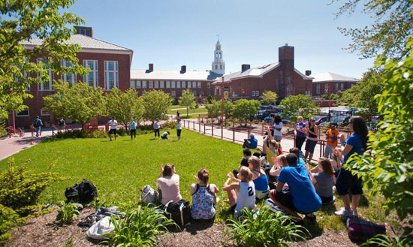**

**PSH 331 Personality (A)**

*Prerequisite PSH 110.*

Application of scientific methods to the study of personality. Topics include research methods and assessment, as well as some of the following substantive approaches: traits, behaviorism/situations, brain anatomy and chemistry, genetics, evolution, psychoanalytic, attachment theory, cross-cultural, and phenomenological perspectives on personality. Emphasis is on research findings and interpretation, but some clinical application is included where appropriate. *3 Cr.*

**PSH 334 Abnormal Psychology (A)**

*Prerequisite PSH 110.*

This course offers a theoretical and empirical framework for understanding the symptoms, causes, and treatment of a range of psychological disorders. Relevant legal, ethical, and diversity issues will also be discussed. *3 Cr.*

**PSH 336 Clinical Psychology (A)**

*Prerequisite PSH 110.*

Provides an empirical overview of clinical psychology, emphasizing the appraisal of assessment strategies and modalities of treatment. Includes research, professional, and ethical issues in clinical psychology. *3 Cr.*

**PSH 441 Clinical Neuropsychology (A)**

*(Prerequisites PSH301 & PSH341 & "PSH322 or PSH 351" & "PSH331 or PSH332" & "PSH834 or PSH484" & "PSH334 or PSH486") or instructor's permission.*

This capstone course introduces human neuropsychological function and disorders in a writing intensive, low-enrollment seminar. Emphasizes methods of neuropsychological investigation and the links between specific brain regions/structures and higher psychological functions. Explores disorders of emotion, motor and social behavior, speech, memory, and visual-spatial abilities associated with organic brain impairments, including Alzheimer's disease, head trauma, stroke, and other neurologic, psychiatric, and medical illnesses. *3 Cr.*

**PSH 445 Psychopharmacology (A)**

*Prerequisites: either PSH 112 or PSH 110, and PSH 341 or instructor's permission.*

Covers the effects of psychoactive substances on the central nervous system, behavior, and mood, with emphasis on the role of neurotransmitter systems and receptor sites in the mechanism of drug actions. Includes the pharmacology of recreational drugs as well as those used in the treatment of psychiatric and neurological disorders. *3 Cr.*

**PSH 488 Developmental Disabilities (A)**

*Prerequisite - PSH110.*

The course will include topics such as: (a) types of developmental disabilities; (b) diagnosis and assessment procedures; (c) causes and prevention; (d) support services and issues across the lifespan; and (e) general treatment approaches and care practices used today and historically. *3 Cr.*

**BIO 221 Survey of Anatomy and Physiology (A,L)**

$25 Course fee required: Credit not applicable to the major in biology. A systems overview of human anatomy and physiology, with emphasis on structure and function of skeletal, muscular, nervous, cardiovascular and respiratory systems. Presents development and integration of these units as a basis for understanding the anatomical and physiological aspects of humans at rest and during activity. Includes a weekly laboratory session. *4 Cr. Every Semester.*

**BIO 281 Elements of Human Biology (A,N)**

Credit not applicable to the major in biology. Provides an introduction for non-majors to the human organism-structure, physiology, metabolism, behavior, genetics, evolution and ecological relationships. Addresses important issues in health and human disease as well as current societal and ethical issues in readings, lectures and classroom discussions. *3 Cr.*

**BIO 315 Cell Biology (A)**

*Prerequisites: BIO 201, BIO 202, CHM 205, and CHM 206.*

Covers cellular structures and functions and the interrelationship between them. Topics include cell components, energy and metabolism, protein structure and function, membranes and transport, cell signaling, cytoskeleton, cell division cycle, and stem cells. *3 Cr. Fall.*

**BIO 489 Neurobiology (A)**

*Prerequisites: BIO 301, or BIO 310&311.*

Fosters the understanding that the brain is the basis of our thoughts, feelings, actions and sense of selves. Advances the idea that brain development and synapse formation play a major role in defining who we are. *3 Cr. Spring.*

**HCS 445 Psychopharmacology of Alcohol and Other Drugs (A)**

*Prerequisite/corequisite: HCS 409.*

Covers the effects of alcohol, sedatives, stimulants, opiates, hallucinogens and other drugs, especially their effects on the central nervous system, behavior and mood. Relates the pharmacokinetics and pharmacodynamics to intoxication tolerance, withdrawal, abuse and dependence of each drug. Includes the learning and motivational components of drug tolerance and addiction. *3 Cr.*

**PRO 481 Medical Technology I (A)**

Provides training through Rochester General Hospital's School of Medical Technology or Women's Christian Association Hospital School of Medical Technology in Jamestown, NY. Teaches several areas under this name that include: Blood Bank, Biochemistry, Hematology, Microbiology, Urinalysis, Mechanisms of Disease, and Independent Research Projects. For admission into this course, students must contact the department chair or the Coordinator of Medical Technology in Lennon Hall nine months prior to the course. 15 Cr. 15 Cr.

# **University of South Carolina**

Spring Semester: early January to early May

Start: 11 jan: <https://www.sc.edu/about/offices_and_divisions/registrar/academic_calendars/2020-21_calendar.php>

Rating #201: <https://www.forbes.com/colleges/university-of-south-carolina/#7f6f7ca36155>

If you are an **undergraduate** student, 12 hours is considered full time.:

<https://www.sc.edu/about/offices_and_divisions/international_student_services/immigration/maintaining-your-immigration-status/full-time-enrollment-requirements/index.php>

2 ECTS = 1 USC Credit

medical insurance

USD1,168 per spring/summer semester. If a student can provide proof of requisite health insurance coverage, this fee may be waived.

Campus looks amazing!!!!!!

Us: 104 rank - ~500 woldwide

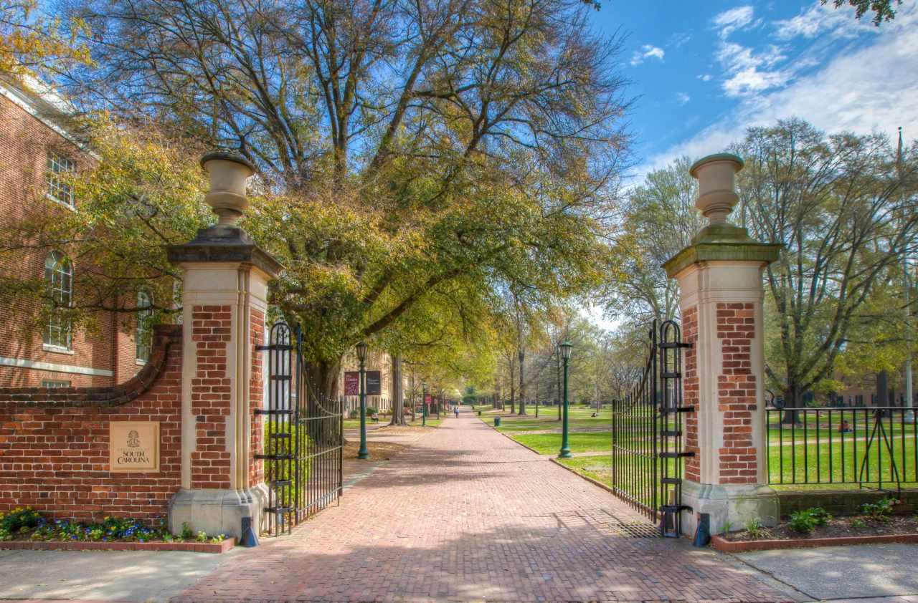

BIOL 243 - Human Anatomy and Physiology I  
Credits: 3  
Functional anatomy and physiology of the human body, including the integumentary, skeletal, muscular, and nervous systems. Not available for biology major credit.  
**Note:** Three lecture hours per week.  
Carolina Core SCI

BIOL 634 - Biology of Neurological Diseases  
Credits: 3  
Advances in molecular and cellular neurobiology that bring new understanding for human neurological disease.   
**Prerequisites:** Introduction to Neuroscience (SCHC 330) and Cell and Molecular Biology (BIOL 302), or Cellular and Molecular Neurobiology (BIOL 405), or Permission of instructor.   
  
PSYC 503 - Psychology of Drug Use and Effects  
Credits: 3  
Research and theoretical considerations of substance abuse. Pharmacological, sociological, psychological, medical, economic, forensic, and other relevant research and treatment disciplines.  
**Prerequisites:** PSYC 450 or PSYC 455 or PSYC 460 or consent of instructor  
**Note:** Carolina Core Integrative Course, Psychology, BA, BS

PSYC 560 - Advanced Topics in Neuroscience  
Credits: 3  
Intensive study of topics selected from the field of neuroscience.  
**Prerequisites:** PSYC 455 or 460

PSYC 570 - Neuroscience Laboratory  
Credits: 3  
Practice in surgical, histological, and behavioral testing methodology. Two lectures and one three-hour laboratory per week.  
**Prerequisites:** PSYC 455 or 460 or consent of instructor  
  
PSYC 571 - Cognitive Neuroscience Laboratory  
Credits: 3  
Methods of observation and experimentation in cognitive neuroscience. Two lectures and one three-hour laboratory per week.  
**Prerequisite or Corequisite:**  
One course from PSYC 400, 405, 450, 455, or 460  
**Prerequisites:** PSYC 226 and 227

PSYC 455 - Introduction to Neuroscience

Credits: 3

Function of the brain including basic neuroanatomy, neurophysiology and neurochemistry, neural systems, and psychopharmacology as it relates to behavior.

PSYC 450 - Sensation and Perception  
Credits: 3  
Processing of information from the environment. Physiological, physical, psychological, and contextual determinants of perception  
**Prerequisites:** PSYC 101 or SCHC 130  
**Note:** Carolina Core Integrative Course, Psychology, BA, BS

BMEN 345 - Human Anatomy and Physiology for Biomedical Engineers  
Credits: 4  
Foundations for biomedical engineering with a focus on human anatomy and physiology. Introduction to the inter-relationships between tissue/organ structure and function; demonstration of how an engineering approach can promote understanding of these relationships. Recent biomedical engineering advances and their relations to underlying anatomy and physiology.  
**Prerequisites:** BMEN 271, C or better in BIOL 302 or BMEN 240  
**Note:** Graduation with Leadership Distinction: Research

PSYC 410 - Behavioral and Mental Disorders  
Credits: 3  
Covers the classification, diagnosis, etiological theories, and treatments of the major mental and emotional disorders.  
**Prerequisites:** PSYC 101 or SCHC 130  
**Note:** Carolina Core Integrative Course, Psychology, BA, BS

CRJU 426 - Criminal Justice and Mental Health

Credits: 3

Interface between the mental health sciences and the criminal justice system.

**Note:** Carolina Core Integrative Course, Criminology and Criminal Justice, B.A.

# **University of Oklahoma**

Minimum: 12 OU credits  
Maximum: 15 OU credits

Students must demonstrate access to $7500 US

Class begins ~13th of January

Rank: [https://www.usnews.com/best-colleges/university-of-oklahoma-3184 - national 132](https://www.usnews.com/best-colleges/university-of-oklahoma-3184%20-%20national%20132)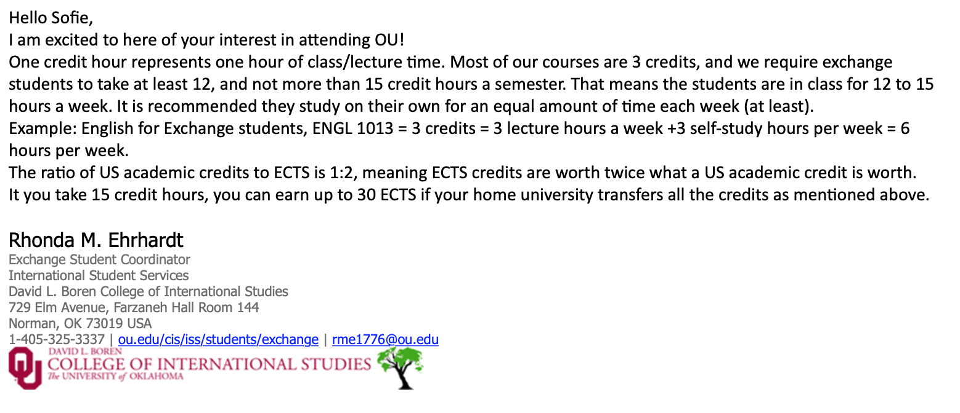

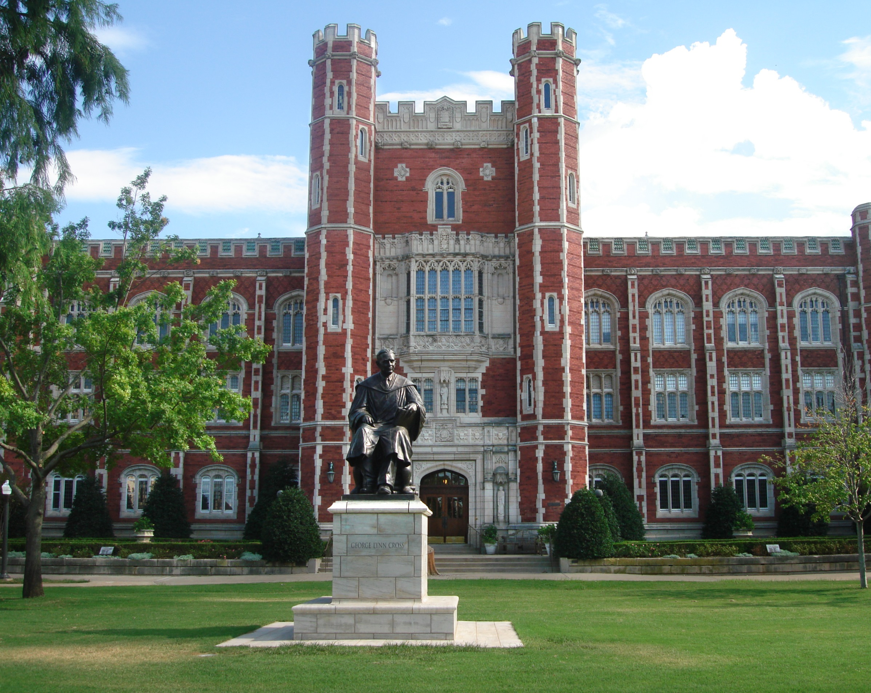

**2124 Human Physiology.** Prerequisite: 1114 and 1121 with a grade of C or better, or 1124 with a grade of C or better; a course in chemistry or physics. May not be applied for zoology major credit. Open only to majors in nursing, physical therapy, health and exercise science, and selected fields. Function of vertebrate organ systems in homeostasis. Circulation, digestion, endocrine and nervous control, metabolism, muscle action and respiration, with emphasis on humans. **Laboratory** (F, Sp, Su)

**5863 Neural Control of Movement (Slashlisted with 5863).** Prerequisite: ZOO 3103 or ZOO 3113, or ZOO 4833/ZOO 5833, or permission of instructor. Introduction to neural control of movement through reading and discussion of key original research articles from the 19th century to the present. Students lead discussions and write essays addressing a general question, utilizing data from the articles; students in 5863 write an additional essay. Topics include localization of function, sensory vs. central contributions, roles of single neurons, effects of neuromodulators, and motor learning. No student may earn credit for both 4863 and 5863. (Sp)

**4871 Current Topics in Neurobiology (Slashlisted with 5871)**. Prerequisite:  Permission of the instructor.  May be repeated; Maximum credit three hours.  A seminar course designed to develop a student’s abilities to interpret and critically evaluate research in cellular and behavioral neurobiology.  Involves both public seminars and journal club style discussions of contemporary literature.  No student may earn credit for both 4871 and 5871.  (F, Sp)

**3803 Physiological Psychology**.

*Prerequisite: 1113 or equivalent and Zoology 1114 or equivalent.* An introduction to physiological and neurological foundations of behavior. Some emphasis will be placed on contemporary issues and theoretical models. (F, Sp)

**4453 Abnormal Psychology**.

*Prerequisite: 1113, 2003/2113, and 2403, or permission of instructor.*An examination of the major clinical and research findings in the field of abnormal psychology. Topics include studies of conflict, anxiety, neurosis, character disorders, schizophrenia and psychotherapy. (F, Sp)

**2234 Introduction to Human Anatomy.** Prerequisite: 1114 and 1121 with a grade of C or better, or 1124 with a grade of C or better, sophomore standing, and permission of department. (Cannot be enrolled concurrently with 2255). An introduction to the gross morphology of the human body. The course will use a lab/lecture format with extensive use of models, videos, and computer-assisted instruction as well as prosected cadavers. Not for zoology major credit. (F)

**3833 - Introduction to Neurobiology**

Prerequisite: BIOL 1124. Introduction to cellular and behavioral neurobiology. Topics covered will include cellular neurobiology, neurophysiology, neuroanatomy, sensory processing, movement, and neurobiology of behavior. (Sp)

**6843 -Neuromuscular Physiology**

Prerequisite: 5823 or permission of instructor. This course examines the structure and function of the central and peripheral nervous systems and skeletal muscle. Emphasis will be placed on how the central nervous system and motor units respond to conditions such as fatigue, exercise training, vibration, stretching, injury and disease. Laboratory (Irreg.)

**2234 - Lab-BIOL 2234-010**

Prerequisite: BIOL 1114 and BIOL 1121 with a grade of C or better, or BIOL 1124 with a grade of C or better, sophomore standing. (Cannot be enrolled concurrently with BIOL 2255). Open only to majors in health and exercise science, physical therapy, nursing and selected fields. See http://biology.ou.edu/human\_anatomy-physiology.htm for complete list. An introduction to the gross morphology of the human body. The course will use a lab/lecture format with extensive use of models, videos, and computer-assisted instruction as well as prosected cadavers. Not for biology major credit. (F)

# **University of misissipi**

30 ECTS = 12 units

Housing secured

Undergrad courses: 100-500

401 national on forbes

Jan 19th (class begins)

**CSD 526: Neurogenic Disorders of Language**

Study of the fundamentals of neurolinguistics; clinical problems of aphasia and traumatic brain injury; other clinical applications and neurolinguistics across the life span.

Prerequisite requirements for this course may also be satisfied by consent of instructor.

3 Credits

**PREREQUISITES**

1. [CSD 505: Neurophysiology and Genetics of Communic](http://catalog.olemiss.edu/csd-505) (Minimum grade: C)

**CSD 505: Neurophysiology and Genetics of Communic**

[**COMMUNICATION SCIENCES & DISORDERS**](http://catalog.olemiss.edu/applied-sciences/communication-sciences-disorders/courses)

Neuroanatomical, neurophysiological, and genetic bases of sensory, central, and motor aspects of language.

3 credits

PREREQUISITES

* [CSD 205: Anatomy and Physiology](http://catalog.olemiss.edu/csd-205) (Minimum grade: C)

Prerequiste: Junior standing (60 hr).

CSD 455: Neuroanat & Neurophys of Speech & Hearin

[COMMUNICATION SCIENCES & DISORDERS](http://catalog.olemiss.edu/applied-sciences/communication-sciences-disorders/courses)

Neuroanatomical and neurophysiological bases of speech, language, and auditory processes.

3 Credits

PREREQUISITES

Pre-Requisite: 24 Earned Hours

**Bisc 543: Functional Neuroanatomy**

[**BIOLOGY**](http://catalog.olemiss.edu/liberal-arts/biology/courses)

An in-depth examination of the structure and function of the vertebrate central nervous system.

3 Credits

PREREQUISITES

* Bisc 327 & (Bisc 330 or 331) or B min in Psy 319 or Graduate Standing.

**Neu 579: Advanced Topics in Neuroscience**

[**COLLEGE OF LIBERAL ARTS**](http://catalog.olemiss.edu/liberal-arts/courses)

May be repeated once for credit with a change in topic.

1 - 4 Credits

PREREQUISITES

* Instructor Approval Required
* Neuroscience director approval required.

**Psy 311: Abnormal Psychology**

[**PSYCHOLOGY**](http://catalog.olemiss.edu/liberal-arts/psychology/courses)

The characteristics, causes, and treatment of abnormal behavior.

3 Credits

PREREQUISITES

* [Psy 201: General Psychology](http://catalog.olemiss.edu/psy-201) (Minimum grade: C)
* Pre-Requisite: 24 Earned Hours

**Psy 319: Brain and Behavior**

[**PSYCHOLOGY**](http://catalog.olemiss.edu/liberal-arts/psychology/courses)

Survey of brain mechanisms that underlie sensation and perception, motivation and emotion, learning and memory, and various clinical disorders.

3 Credits

PREREQUISITES

* Prerequisite Bisc 160(C) or ( Psy 201(C) and Bisc 102(C) ).
* Pre-Requisite: 24 Earned Hours

# **UNIVERSITY OF MASSACHUSETTS BOSTON, UNITED STATES**

12-17 credits (4 courses) for undergraduates

#524 forbes ranking: <https://www.forbes.com/colleges/university-of-massachusetts-boston/#2542368b5959>

27th of January semester starts

ECTS 2 = 1 credit - <https://www.tcd.ie/study/assets/PDF/ECTS_Equivalents_Credit_Table_UK.pdf>

**PSYCH 360 - Behavioral Neuroscience**

*3* *Credit(s)* | *Lecture* |

**Description:**

An overview of the field of neuroscience. Selected topics are neuroanatomy, brain physiology, communication in the central nervous system, immunology, and psychopharmacology. This course also includes a critical discussion of various research techniques. One goal for students is to develop critical thinking skills, as consumers of scientific information.

*Prerequisites:*

1. [PSYCH 100](http://catalog.umb.edu/search_advanced.php?cur_cat_oid=28&ecpage=1&cpage=1&ppage=1&pcpage=1&spage=1&tpage=1&search_database=Search&filter%5Bkeyword%5D=Neuroscience&filter%5B3%5D=1&filter%5B31%5D=1&filter%5B1%5D=1&filter%5B28%5D=1&filter%5B30%5D=1#tt3388) or [PSYCH 101](http://catalog.umb.edu/search_advanced.php?cur_cat_oid=28&ecpage=1&cpage=1&ppage=1&pcpage=1&spage=1&tpage=1&search_database=Search&filter%5Bkeyword%5D=Neuroscience&filter%5B3%5D=1&filter%5B31%5D=1&filter%5B1%5D=1&filter%5B28%5D=1&filter%5B30%5D=1#tt3262)  and
2. PSYCH 105 or any BIOL course

**BIOL 316 - Neurobiology**

*4* *Credit(s)* | *Lecture and Laboratory* |

**Description:**

Examination of the nervous system, beginning at the membrane and cellular level and then moving on to the organization of sensory and motor systems. Special topics include the biological basis of various neurological and psychiatric diseases. Note: Students who do not wish to take the laboratory portion of this course should register for [BIOL 318](http://catalog.umb.edu/search_advanced.php?cur_cat_oid=28&ecpage=1&cpage=1&ppage=1&pcpage=1&spage=1&tpage=1&search_database=Search&filter%5Bkeyword%5D=Neuro&filter%5B3%5D=1&filter%5B31%5D=1&filter%5B1%5D=1&filter%5B28%5D=1&filter%5B30%5D=1#tt3289). (No student may take this course after successful completion of [BIOL 318](http://catalog.umb.edu/search_advanced.php?cur_cat_oid=28&ecpage=1&cpage=1&ppage=1&pcpage=1&spage=1&tpage=1&search_database=Search&filter%5Bkeyword%5D=Neuro&filter%5B3%5D=1&filter%5B31%5D=1&filter%5B1%5D=1&filter%5B28%5D=1&filter%5B30%5D=1#tt1162).)

*Prerequisites:*

* [BIOL 210](http://catalog.umb.edu/search_advanced.php?cur_cat_oid=28&ecpage=1&cpage=1&ppage=1&pcpage=1&spage=1&tpage=1&search_database=Search&filter%5Bkeyword%5D=Neuro&filter%5B3%5D=1&filter%5B31%5D=1&filter%5B1%5D=1&filter%5B28%5D=1&filter%5B30%5D=1#tt4090) or [BIOL 212](http://catalog.umb.edu/search_advanced.php?cur_cat_oid=28&ecpage=1&cpage=1&ppage=1&pcpage=1&spage=1&tpage=1&search_database=Search&filter%5Bkeyword%5D=Neuro&filter%5B3%5D=1&filter%5B31%5D=1&filter%5B1%5D=1&filter%5B28%5D=1&filter%5B30%5D=1#tt5487) and
* [BIOL 252](http://catalog.umb.edu/search_advanced.php?cur_cat_oid=28&ecpage=1&cpage=1&ppage=1&pcpage=1&spage=1&tpage=1&search_database=Search&filter%5Bkeyword%5D=Neuro&filter%5B3%5D=1&filter%5B31%5D=1&filter%5B1%5D=1&filter%5B28%5D=1&filter%5B30%5D=1#tt2980) or [BIOL 254](http://catalog.umb.edu/search_advanced.php?cur_cat_oid=28&ecpage=1&cpage=1&ppage=1&pcpage=1&spage=1&tpage=1&search_database=Search&filter%5Bkeyword%5D=Neuro&filter%5B3%5D=1&filter%5B31%5D=1&filter%5B1%5D=1&filter%5B28%5D=1&filter%5B30%5D=1#tt5659)

Non-biology majors may seek permission of instructor

**PSYCH 460 - The Neuropsychology of Higher Cognitive Processes**

*3* *Credit(s)* | *Lecture* |

Course can be counted for credit once

**Description:**

The neural basis of higher cognitive functions, such as perception, language, and memory, including a consideration of human brain damage and psychological tests used to assess such damage.

*Prerequisites:*

* [PSYCH 201](http://catalog.umb.edu/search_advanced.php?cur_cat_oid=28&ecpage=1&cpage=1&ppage=1&pcpage=1&spage=1&tpage=1&search_database=Search&filter%5Bkeyword%5D=Neuro&filter%5B3%5D=1&filter%5B31%5D=1&filter%5B1%5D=1&filter%5B28%5D=1&filter%5B30%5D=1#tt2948) and
* [PSYCH 360](http://catalog.umb.edu/search_advanced.php?cur_cat_oid=28&ecpage=1&cpage=1&ppage=1&pcpage=1&spage=1&tpage=1&search_database=Search&filter%5Bkeyword%5D=Neuro&filter%5B3%5D=1&filter%5B31%5D=1&filter%5B1%5D=1&filter%5B28%5D=1&filter%5B30%5D=1#tt9604) or equivalent

**PSYCH 466 - Hormones and Behavior**

*3* *Credit(s)* | *Lecture* |

**Description:**

This course studies relationships between behavior and the neuroendocrine system studied in diverse behavioral systems of animals, including humans. Participants acquire an understanding of the complex interactions between hormones and behavior; study endocrine bases of sex differences, reproduction, affiliation, aggression, homeostasis, biorhythms, and other behavioral systems; explore clinical implications; and learn to read, evaluate, and discuss original research findings.

*Prerequisites:*[PSYCH 201](http://catalog.umb.edu/search_advanced.php?cur_cat_oid=28&ecpage=1&cpage=1&ppage=1&pcpage=1&spage=1&tpage=1&search_database=Search&filter%5Bkeyword%5D=Neuro&filter%5B3%5D=1&filter%5B31%5D=1&filter%5B1%5D=1&filter%5B28%5D=1&filter%5B30%5D=1#tt7037) and [PSYCH 360](http://catalog.umb.edu/search_advanced.php?cur_cat_oid=28&ecpage=1&cpage=1&ppage=1&pcpage=1&spage=1&tpage=1&search_database=Search&filter%5Bkeyword%5D=Neuro&filter%5B3%5D=1&filter%5B31%5D=1&filter%5B1%5D=1&filter%5B28%5D=1&filter%5B30%5D=1#tt3577)

**PSYCH 468 - Science of Human Sexuality**

*3* *Credit(s)* | *Lecture* |

**Description:**

This course introduces the topic of human sexuality in an evidence-based, scientific manner, focusing especially on its biological and neurobiological underpinnings. The class also explores the history and methods of sex research, including animal behavior research, sexual evolution, sexual differentiation of body and brain anatomy, the nature of physical attractiveness, as well as scientific study of the wide range of human sexual behaviors.

*Prerequisites:*

* [PSYCH 201](http://catalog.umb.edu/search_advanced.php?cur_cat_oid=28&ecpage=1&cpage=1&ppage=1&pcpage=1&spage=1&tpage=1&search_database=Search&filter%5Bkeyword%5D=Neuro&filter%5B3%5D=1&filter%5B31%5D=1&filter%5B1%5D=1&filter%5B28%5D=1&filter%5B30%5D=1#tt4511) and
* [PSYCH 360](http://catalog.umb.edu/search_advanced.php?cur_cat_oid=28&ecpage=1&cpage=1&ppage=1&pcpage=1&spage=1&tpage=1&search_database=Search&filter%5Bkeyword%5D=Neuro&filter%5B3%5D=1&filter%5B31%5D=1&filter%5B1%5D=1&filter%5B28%5D=1&filter%5B30%5D=1#tt7993) or [BIOL 316](http://catalog.umb.edu/search_advanced.php?cur_cat_oid=28&ecpage=1&cpage=1&ppage=1&pcpage=1&spage=1&tpage=1&search_database=Search&filter%5Bkeyword%5D=Neuro&filter%5B3%5D=1&filter%5B31%5D=1&filter%5B1%5D=1&filter%5B28%5D=1&filter%5B30%5D=1#tt3659)

**BIOL 210 - Cell Biology**

*4* *Credit(s)* | *Lecture and Laboratory* |

**Description:**

A study of structure and function of cells including physiological and biochemical processes of cells, membranes, subcellular organelles, and of specialized cells. Specific topics include synthesis and mode of action of biological macromolecules, flow of information and energy, mode of enzyme action, cell-to-cell communication, and membrane functions such as transport. Note: Students (non-biology majors) who do not wish to take the laboratory portion of this course should register for [BIOL 212](http://catalog.umb.edu/search_advanced.php?cur_cat_oid=28&search_database=Search&search_db=Search&cpage=1&ecpage=1&ppage=1&spage=1&tpage=1&location=33&filter%5Bkeyword%5D=BIOL+210#tt8824). No student may take this course after successful completion of [BIOL 212](http://catalog.umb.edu/search_advanced.php?cur_cat_oid=28&search_database=Search&search_db=Search&cpage=1&ecpage=1&ppage=1&spage=1&tpage=1&location=33&filter%5Bkeyword%5D=BIOL+210#tt1803).

*Prerequisite:*

* [BIOL 112](http://catalog.umb.edu/search_advanced.php?cur_cat_oid=28&search_database=Search&search_db=Search&cpage=1&ecpage=1&ppage=1&spage=1&tpage=1&location=33&filter%5Bkeyword%5D=BIOL+210#tt8769) or 902B and
* CHEM 103 or [CHEM 115](http://catalog.umb.edu/search_advanced.php?cur_cat_oid=28&search_database=Search&search_db=Search&cpage=1&ecpage=1&ppage=1&spage=1&tpage=1&location=33&filter%5Bkeyword%5D=BIOL+210#tt5367) and [CHEM 117](http://catalog.umb.edu/search_advanced.php?cur_cat_oid=28&search_database=Search&search_db=Search&cpage=1&ecpage=1&ppage=1&spage=1&tpage=1&location=33&filter%5Bkeyword%5D=BIOL+210#tt3252) or 903A

**PSYCH 478 - Experimental Methods: Personality and Abnormal Psychology**

*3* *Credit(s)* | *Lecture* |

**Description:**

This course immerses students in research literature in personality and abnormal psychology and prepares students to conduct their own empirical research. Students learn how to read and critique research articles, use databases for literature searches, write a literature review, design a research project, analyze data using a statistical package, and write a paper in the form of a journal article.

*Prerequisites:*

* [PSYCH 201](http://catalog.umb.edu/search_advanced.php?cur_cat_oid=28&search_database=Search&search_db=Search&cpage=1&ecpage=1&ppage=1&spage=1&tpage=1&location=33&filter%5Bkeyword%5D=abnormal#tt8520) and
* [PSYCH 210](http://catalog.umb.edu/search_advanced.php?cur_cat_oid=28&search_database=Search&search_db=Search&cpage=1&ecpage=1&ppage=1&spage=1&tpage=1&location=33&filter%5Bkeyword%5D=abnormal#tt4983) or [PSYCH 215](http://catalog.umb.edu/search_advanced.php?cur_cat_oid=28&search_database=Search&search_db=Search&cpage=1&ecpage=1&ppage=1&spage=1&tpage=1&location=33&filter%5Bkeyword%5D=abnormal#tt1563) and
* [PSYCH 370](http://catalog.umb.edu/search_advanced.php?cur_cat_oid=28&search_database=Search&search_db=Search&cpage=1&ecpage=1&ppage=1&spage=1&tpage=1&location=33&filter%5Bkeyword%5D=abnormal#tt9633)

**PSYCH 215 - Abnormal Psychology**

*3* *Credit(s)* | *Lecture* |

**Description:**

This course examines the range of common psychological disorders, their characteristic symptoms, possible causes, and treatment. It takes a critical scientific approach to the criteria used to define psychological abnormality, the theories used to explain it, and the therapies used to treat it. Etiology, dynamics and treatment of psychopathology.

**Enrollment Requirements:**

*Prerequisite:*[PSYCH 100](http://catalog.umb.edu/search_advanced.php?cur_cat_oid=28&search_database=Search&search_db=Search&cpage=1&ecpage=1&ppage=1&spage=1&tpage=1&location=33&filter%5Bkeyword%5D=abnormal#tt2587) or [PSYCH 101](http://catalog.umb.edu/search_advanced.php?cur_cat_oid=28&search_database=Search&search_db=Search&cpage=1&ecpage=1&ppage=1&spage=1&tpage=1&location=33&filter%5Bkeyword%5D=abnormal#tt9043)

**PSYCH 476 - Experimental Methods: Physiological**

*3* *Credit(s)* | *Lecture* |

**Description:**

Lab research on selected topics in physiological psychology, including hormonal influences, brain-behavior relationships, and mechanisms of reward and punishment. Emphasis is on the acquisition of research skills through the use of surgical, histological and statistical techniques in investigations mainly derived from computer-simulated data bases.

**Enrollment Requirements:**

*Prerequisites:*

* [PSYCH 201](http://catalog.umb.edu/search_advanced.php?cur_cat_oid=28&search_database=Search&search_db=Search&cpage=1&ecpage=1&ppage=1&spage=1&tpage=1&location=33&filter%5Bkeyword%5D=brain#tt3007) and
* [PSYCH 360](http://catalog.umb.edu/search_advanced.php?cur_cat_oid=28&search_database=Search&search_db=Search&cpage=1&ecpage=1&ppage=1&spage=1&tpage=1&location=33&filter%5Bkeyword%5D=brain#tt1054) or [BIOL 112](http://catalog.umb.edu/search_advanced.php?cur_cat_oid=28&search_database=Search&search_db=Search&cpage=1&ecpage=1&ppage=1&spage=1&tpage=1&location=33&filter%5Bkeyword%5D=brain#tt1325)

**PSYCH 464 - Biological Rhythms in Brain and Behavior**

*3* *Credit(s)* | *Lecture* |

**Description:**

This course will be an introduction to the field of biological rhythms. In this course, students will examine biological clocks at multiple levels including theoretical aspects, organismal and system level studies, and cellular and molecular analyses. The course will cover numerous examples that illustrate the important impact of rhythms on both psychological and biological functioning.

*Prerequisites:*

* [PSYCH 201](http://catalog.umb.edu/search_advanced.php?cur_cat_oid=28&search_database=Search&search_db=Search&cpage=1&ecpage=1&ppage=1&spage=1&tpage=1&location=33&filter%5Bkeyword%5D=brain#tt8190) and
* [PSYCH 360](http://catalog.umb.edu/search_advanced.php?cur_cat_oid=28&search_database=Search&search_db=Search&cpage=1&ecpage=1&ppage=1&spage=1&tpage=1&location=33&filter%5Bkeyword%5D=brain#tt404) or [BIOL 316](http://catalog.umb.edu/search_advanced.php?cur_cat_oid=28&search_database=Search&search_db=Search&cpage=1&ecpage=1&ppage=1&spage=1&tpage=1&location=33&filter%5Bkeyword%5D=brain#tt3379)

# **UNIVERSITY OF CALIFORNIA, SANTA CRUZ**

#183 forbes ranking



15 units (no more than 19)

1 ECTS = 1.33 quarter units

19 Course points = 25 ECTS – take 5 ECTS during summer

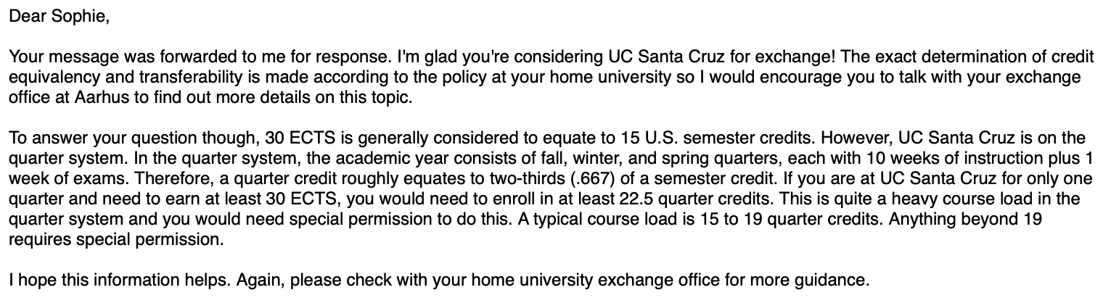

**BIOL 126 Advanced Molecular Neuroscience**

Explores in detail cellular and molecular events that underlay the function of the nervous system. Topics include neural development, axon guidance and regeneration, advanced electrical principles (synaptic transmission through a variety of receptors), synaptic plasticity, learning and memory, as well as several neural disorders. Students cannot receive credit for this course and course 226.

**Requirements**Prerequisite(s): [BIOL 125](https://catalog.ucsc.edu/Current/General-Catalog/Courses/BIOL-Biology-Molecular-Cell-and-Developmental/100/BIOL-125). Enrollment is restricted to neuroscience majors and proposed majors.

**Credits**5

**Quarter Offered**Spring

**BIOL 127 Mechanisms of Neurodegenerative Disease**

Focuses on cellular and molecular processes that underlie neurodegenerative diseases. Includes lectures, student oral presentations, discussions, a term paper, and exams.

**Requirements**Prerequisite(s): [BIOL 110](https://catalog.ucsc.edu/Current/General-Catalog/Courses/BIOL-Biology-Molecular-Cell-and-Developmental/100/BIOL-110).

**Credits**5

**BIOL 228 Developmental Neurobiology**

Covers the principles of nervous-system development from the molecular control of development, and cell-cell interactions, to the role of experience in influencing brain structure and function. Students cannot receive credit for this course and course 128. Enrollment is restricted to graduate students and by permission of the instructor.

**Credits**5

**Quarter Offered**Winter

**BIOL 110 Cell Biology**

Covers the structure, organization, and function of eukaryotic cells. Topics include biological membranes, organelles, protein and vesicular trafficking, cellular interactions, the cytoskeleton, and signal transduction. Requires a good understanding of basic biochemistry and molecular biology.

**Requirements**Prerequisite(s): [BIOL 101](https://catalog.ucsc.edu/Current/General-Catalog/Courses/BIOL-Biology-Molecular-Cell-and-Developmental/100/BIOL-101) or [BIOC 100A](https://catalog.ucsc.edu/Current/General-Catalog/Courses/BIOC-Biochemistry-and-Molecular-Biology/Upper-Division/BIOC-100A); and [BIOL 105](https://catalog.ucsc.edu/Current/General-Catalog/Courses/BIOL-Biology-Molecular-Cell-and-Developmental/100/BIOL-105); and [BIOL 101L](https://catalog.ucsc.edu/Current/General-Catalog/Courses/BIOL-Biology-Molecular-Cell-and-Developmental/100/BIOL-101L) or [BIOL 102L](https://catalog.ucsc.edu/Current/General-Catalog/Courses/BIOL-Biology-Molecular-Cell-and-Developmental/100/BIOL-102L) or [BIOL 20L](https://catalog.ucsc.edu/Current/General-Catalog/Courses/BIOL-Biology-Molecular-Cell-and-Developmental/1-99/BIOL-20L).

**Credits**5

**Quarter Offered**Fall, Winter, Spring

**BIOL 128 Developmental Neurobiology**

Covers the principles of nervous-system development from the molecular control of development, cell-cell interactions, to the role of experience in influencing brain structure and function. Students cannot receive credit for this course and course 228.

**Requirements**Prerequisite(s): [BIOL 110](https://catalog.ucsc.edu/Current/General-Catalog/Courses/BIOL-Biology-Molecular-Cell-and-Developmental/100/BIOL-110) and [BIOL 125](https://catalog.ucsc.edu/Current/General-Catalog/Courses/BIOL-Biology-Molecular-Cell-and-Developmental/100/BIOL-125). Enrollment is restricted to juniors and seniors.

**Credits**5

**Quarter Offered**Winter

**PSYC 170 Abnormal Psychology**

Survey of theory, research, and intervention in human psychopathology. Covers psychological, biological, developmental, and socio-cultural approaches.

**Requirements**Prerequisite(s): [PSYC 100](https://catalog.ucsc.edu/Current/General-Catalog/Courses/PSYC-Psychology/Upper-Division/PSYC-100); [PSYC 60](https://catalog.ucsc.edu/Current/General-Catalog/Courses/PSYC-Psychology/Lower-Division/PSYC-60) highly recommended as preparation.

**Credits**5

**Quarter Offered**Winter, Spring, Summer

**PSYC 130 Deception, Brain, and Behavior**

Focuses on behavioral and brain manifestations of deception. Topics include developmental changes that allow us to understand and to use deception, physical implications of lying expressed in the face, voice, posture, and brain activity. Also covers mechanical or behavioral techniques used in deceptive behavior, whether in the form of overt behavior or brain activity.

**Requirements**Prerequisite(s): [PSYC 100](https://catalog.ucsc.edu/Current/General-Catalog/Courses/PSYC-Psychology/Upper-Division/PSYC-100); and [PSYC 20](https://catalog.ucsc.edu/Current/General-Catalog/Courses/PSYC-Psychology/Lower-Division/PSYC-20) or any upper-division cognitive course. Enrollment is restricted to psychology and cognitive science majors and minors.

**Credits**5

# **UC collection**

Davis:  
På bachelor niveau udgører hver quarter 15 quarter credits. 1 Davis-credit tilsvarer 1,33 ECTS. Anbefalt antall credits/quarter er 15 credits som da tilsvarer 20 ECTS.

Irene

undergraduate enrollment will be limited to 18 units: <http://catalogue.uci.edu/informationforadmittedstudents/registrationandotherprocedures/>

De fleste fag er 4 units. 18 til 23 units på University of California Irvine svarer ca. til 30 ECTS

<https://www.studysea.dk/universiteter-i-udlandet/university-of-california-irvine/>

Mercede

1 unit = 2 ECTS

<https://engr-advising.ucmerced.edu/policies/normal-progress>: 15 units pr semester

Riverside:

For students in good standing, enrollment is allowed in a maximum of 18 units without the need for advisor's permission. Enrolling in 19 or 20 units is possible if: your cumulative GPA is 3.0 or above; or, if your cumulative GPA is below 3.0 and you have an approved petition. Enrollment in more than 20 units always requires a petition. : <https://student.engr.ucr.edu/policies/maximum-units>

4 American Credits entsprechen 7,5 ECTS: https://www.ebc-hochschule.de/fileadmin/PDF-Partnerhochschulen/University%20of%20California,%20Riverside.pdf

18 credits = 33 ECTS

Santa Barbra ??? – no academic calender or ECTS or number of units

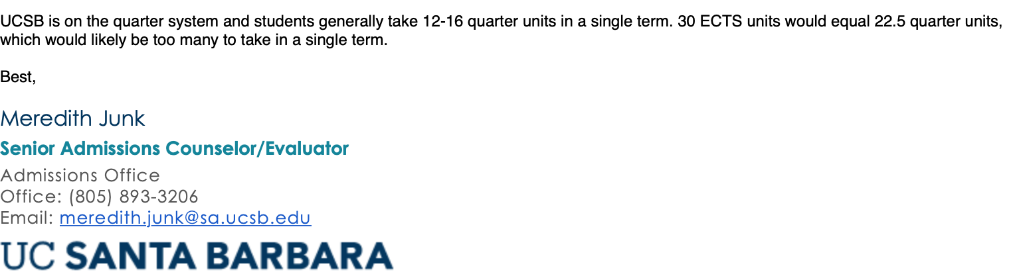

## BEREKLY

Start: 14th of january

15 units = 30 ECTS

#13: <https://www.forbes.com/colleges/university-of-south-carolina/#7f6f7ca36155>

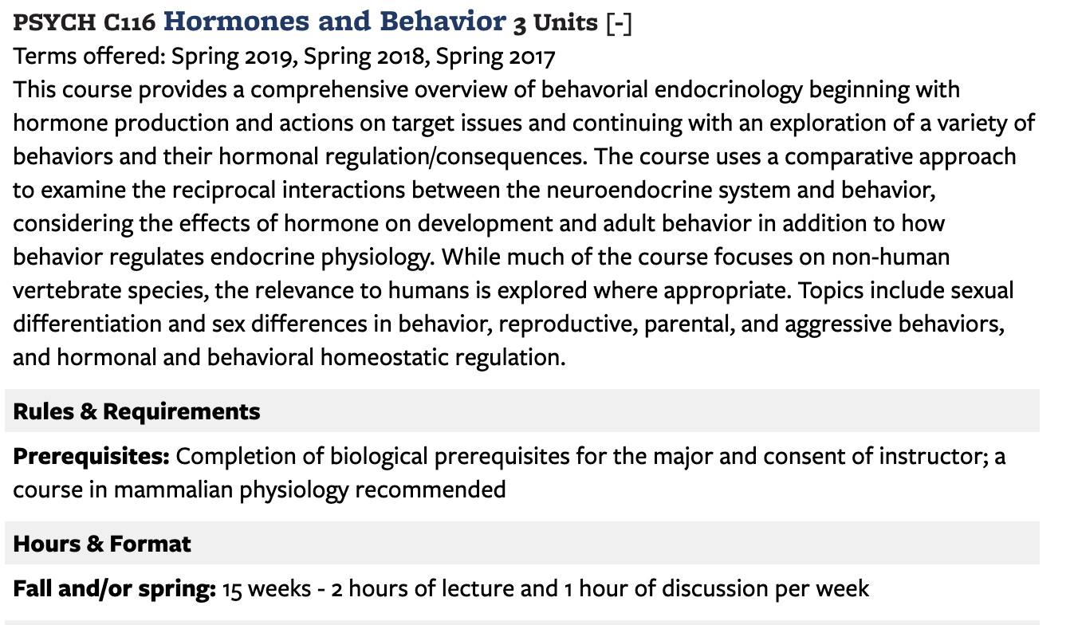Hu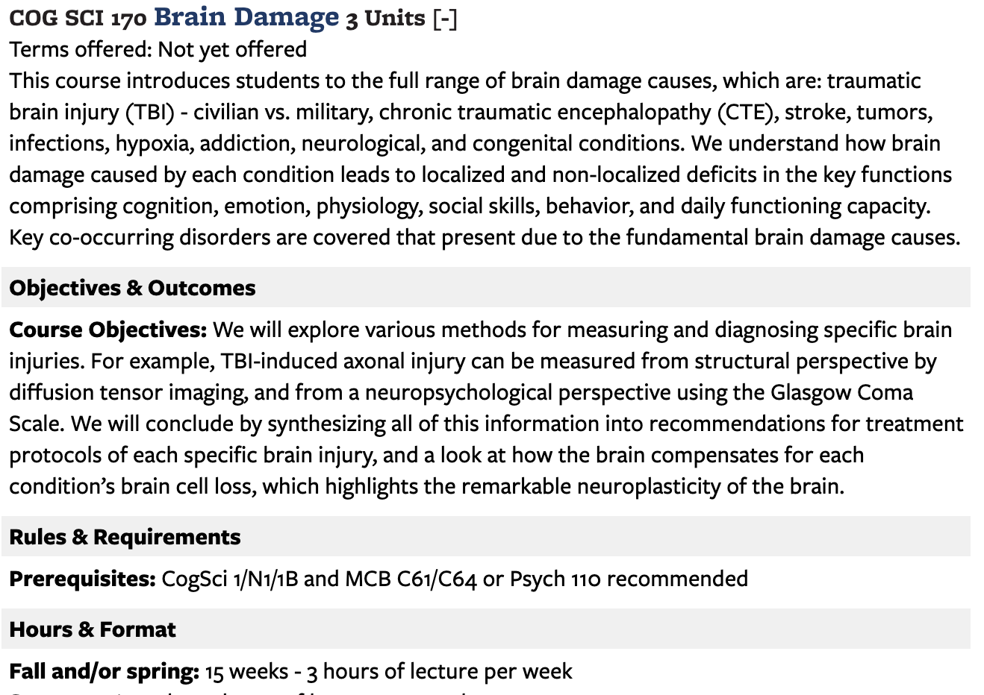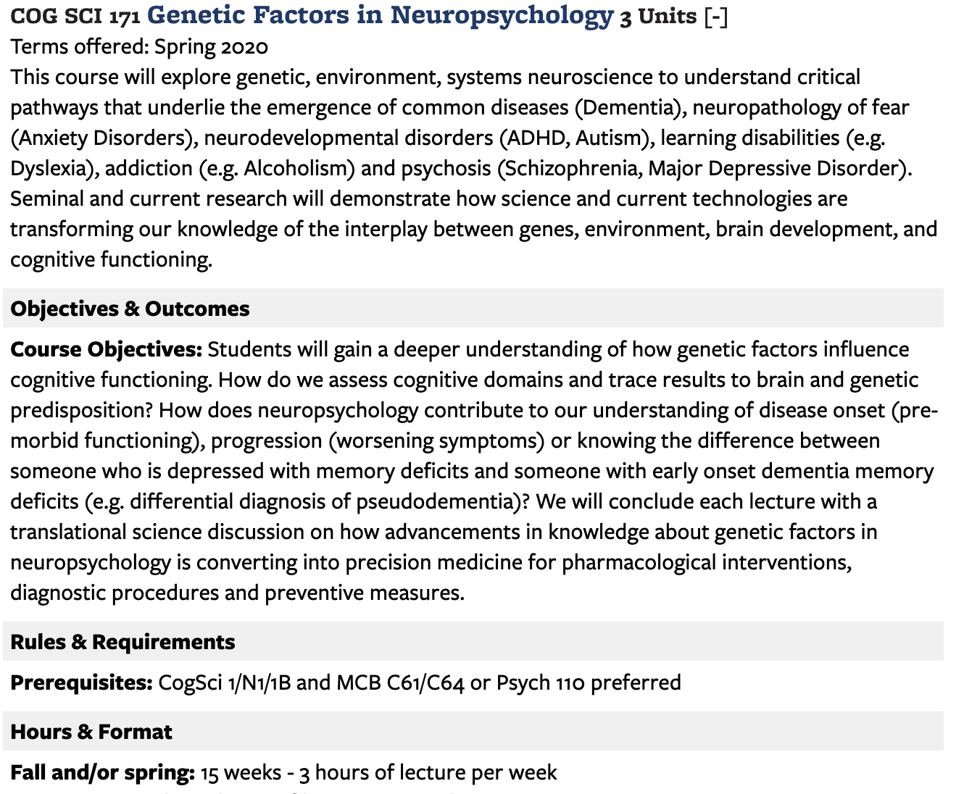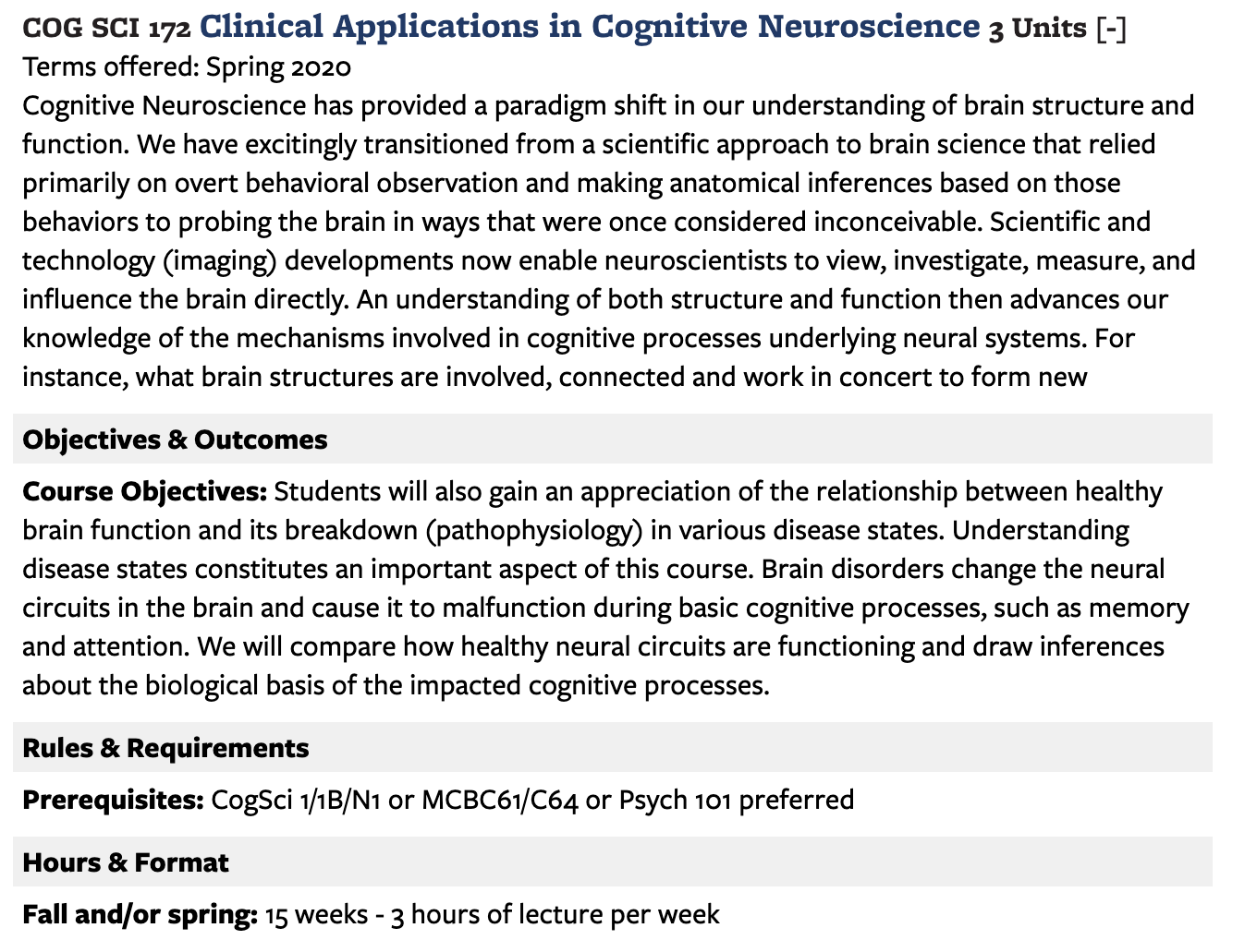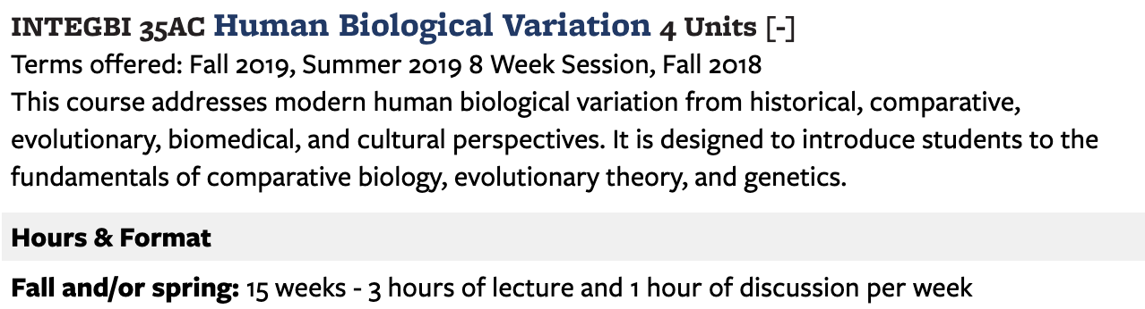

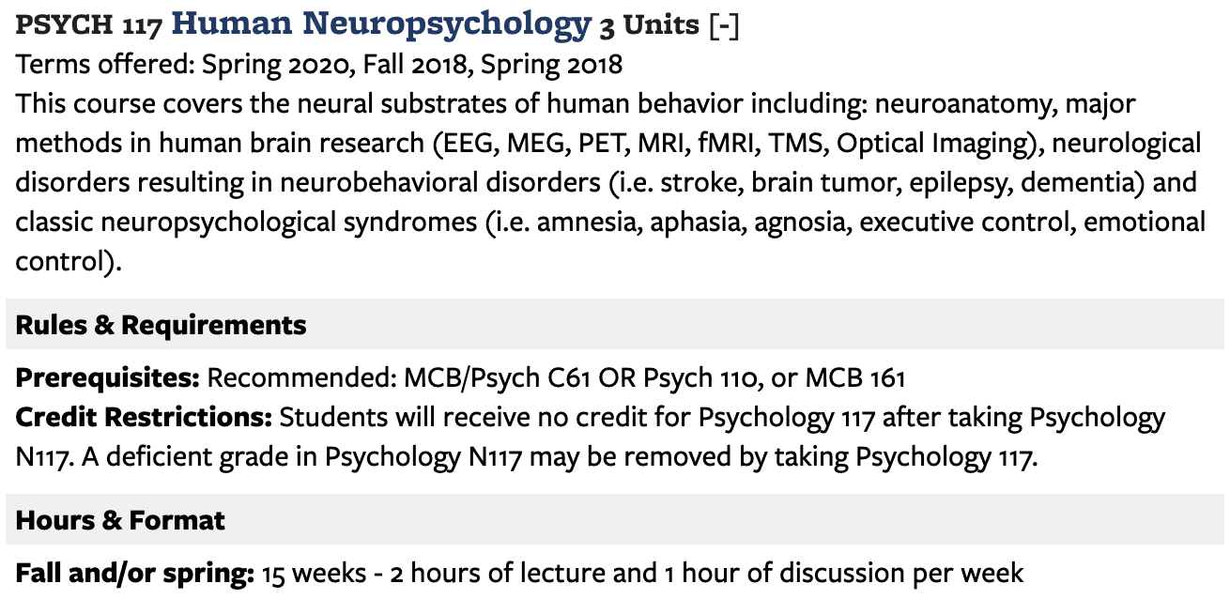

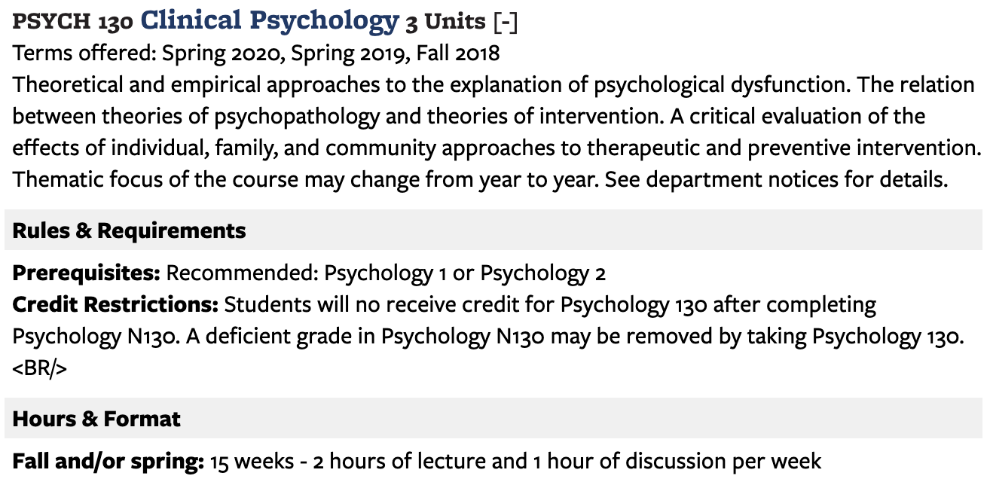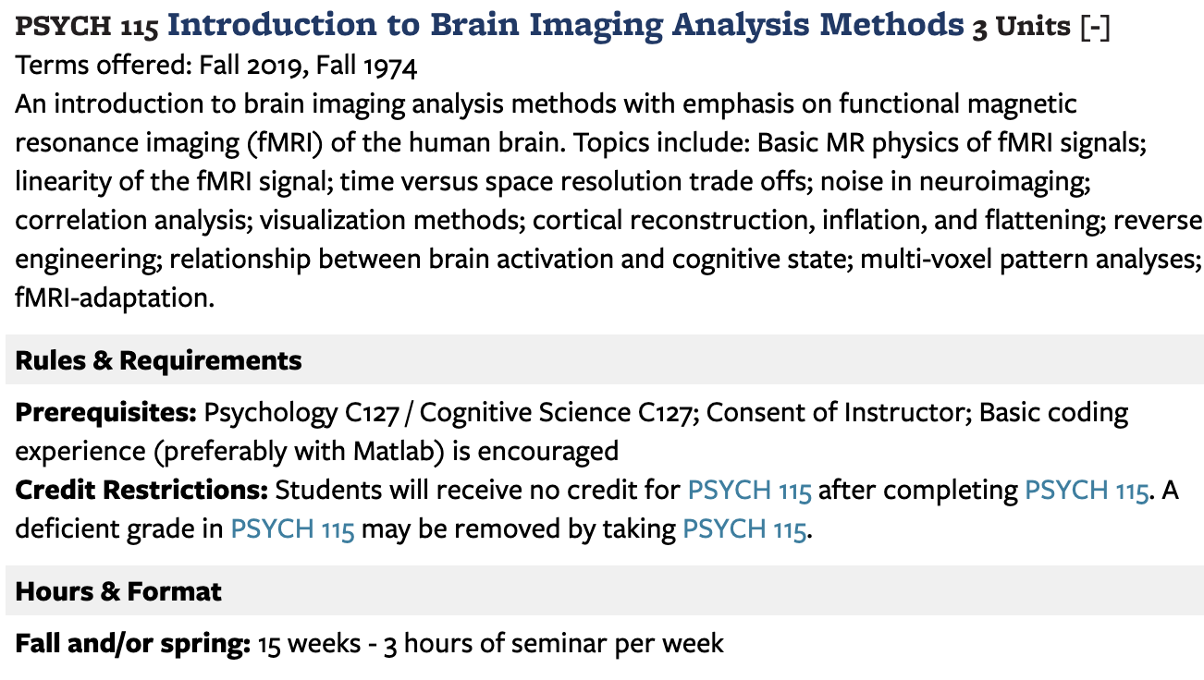

**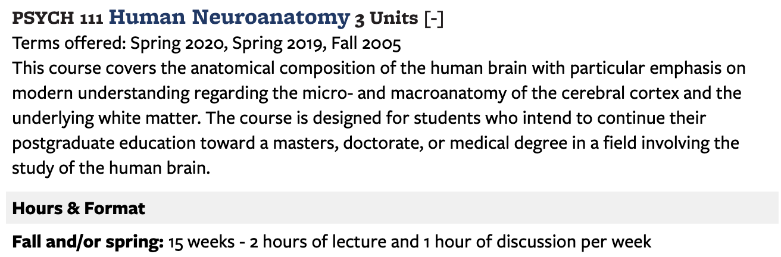**

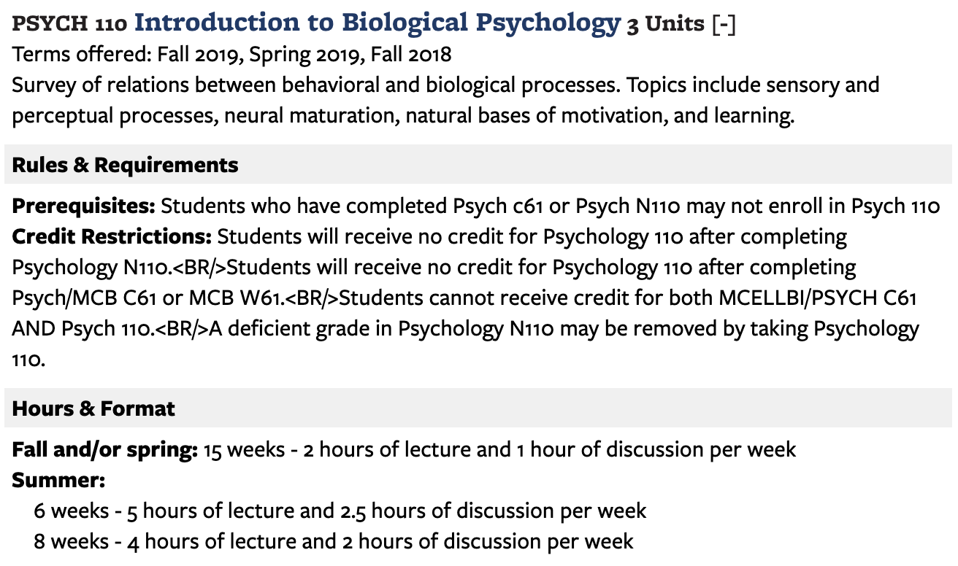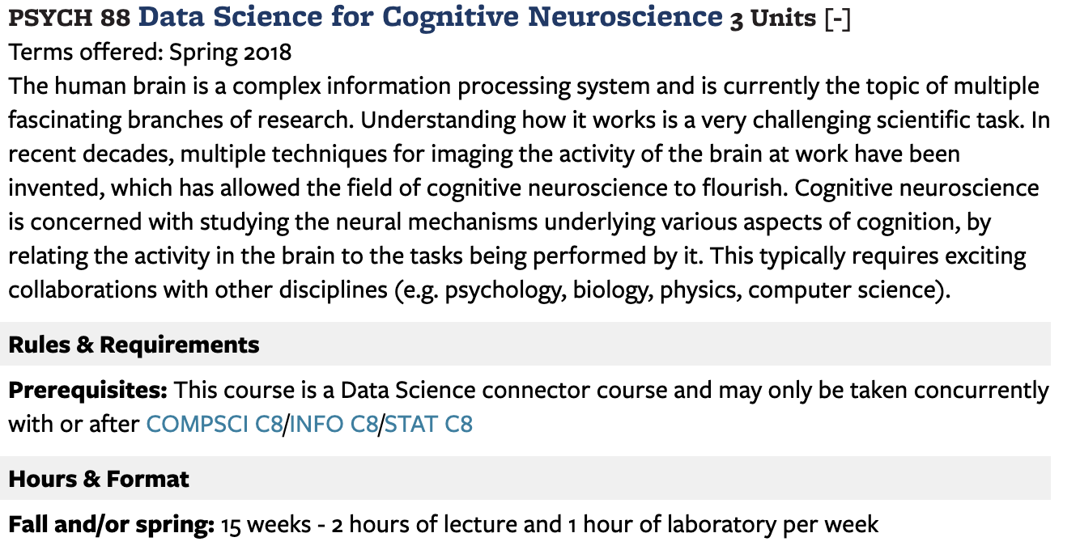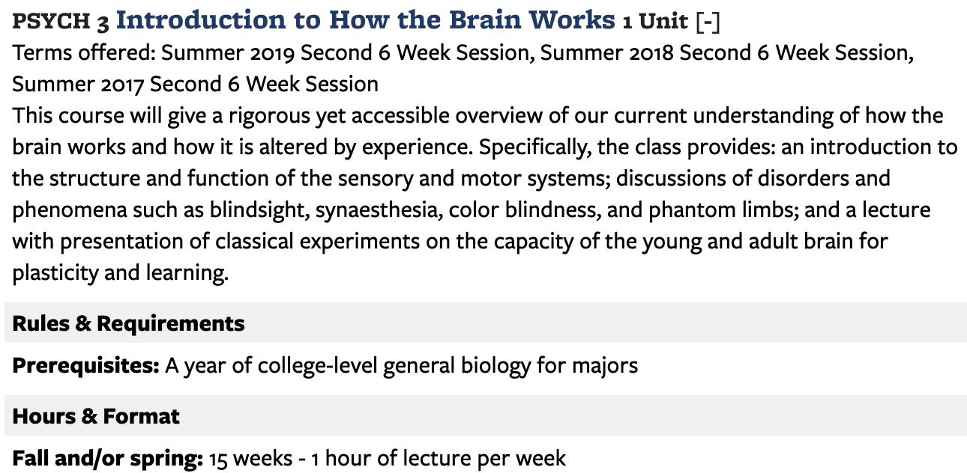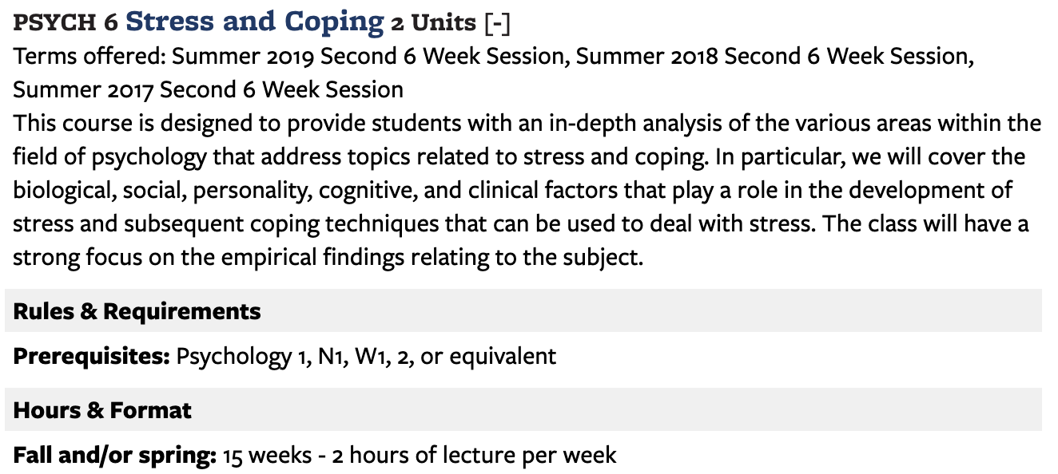

## UCLA

Forbes: #38

Winter: 4th january, spring: March 24

1 term (15 credit units) will be transferred with 20 ECTS. To obtain 30 ECTS it will be necessary to spend 2 terms at UCLA

**M101A. Neuroscience: From Molecules to Mind--Cellular and Systems Neuroscience**

Units: 5

(Same as Molecular, Cell, and Developmental Biology M175A, Physiological Science M180A, and Psychology M117A.) Lecture, four hours; discussion, 90 minutes. Requisites: Chemistry 14C or 30A (14C may be taken concurrently), Life Sciences 2 or 7C, Physics 1B or 1BH or 5C or 6B. Not open for credit to students with credit for Physiological Science 111A. For Neuroscience and Physiological Science majors, grade of C- or better is required to proceed to Neuroscience M101B or Physiological Science 111B. Cellular neurophysiology, membrane potential, action potentials, and synaptic transmission. Sensory systems and motor system; how assemblies of neurons process complex information and control movement. P/NP or letter grading.

**102. Introduction to Functional Anatomy of Central Nervous System**

Units: 4

Lecture, three hours; laboratory, one hour. Requisite: Life Sciences 2 or 7C. Corequisite: course M101A. Not open to freshmen. Overview of human nervous system; relation of behavior to higher cognitive function. Development of primate and human brain during past few million years; evolutionary aspects of neuroanatomical structures and effects of behavior and cultural attitudes of modern man. P/NP or letter grading.

**M119L. Human Neuropsychology**

Units: 4

(Same as Psychology M119L.) Lecture, three hours. Recommended requisites: courses M101A and M101C (or Psychology 115), Psychology 120A or 120B. Designed for juniors/seniors. Survey of experimental and clinical human neuropsychology; neural basis of higher cognitive functions. P/NP or letter grading.

**M130. Biological Bases of Psychiatric Disorders**

Units: 4

(Same as Molecular, Cell, and Developmental Biology M181, Physiological Science M181, Psychiatry M181, and Psychology M117J.) Lecture, three hours. Requisite: course M101A (or Molecular, Cell, and Developmental Biology M175A or Physiological Science M180A or Psychology M117A) or Physiological Science 111A or Psychology 115. Underlying brain systems involved in psychiatric symptoms and neurological disorders, including schizophrenia, depression, bipolar disorder, obsessive/compulsive disorder. Provides basic understanding of brain dysfunctions that contribute to disorders and rationales for pharmacological treatments. P/NP or letter grading.

**C172. Neuroimaging and Brain Mapping**

Units: 4

Lecture, three hours. Requisite: course M101A (or Molecular, Cell, and Developmental Biology M175A or Physiological Science M180A or Psychology M117A) or Physiological Science 111A or Psychology 115. Strongly recommended: course 102. Theory, methods, applications, assumptions, and limitations of neuroimaging. Techniques, biological questions, and results. Brain structure, brain function, and their relationship discussed with regard to imaging. Concurrently scheduled with course CM272. Letter grading.

**C177. Drugs of Abuse: Translational Neurobiology**

Units: 4

Lecture, four hours. Requisite: course M101A. Course ranges from synapse to society. Provides intensive didactic on current neuroscientific basis for understanding substance abuse and blends that material with relevant topics such as epidemiology, co-occurring disorders, treatment options, prevention, and public policies, with emphasis on communication of course materials to general public. Concurrently scheduled with course C277. Letter grading.

**179. Clinical Neuroscience: New Concepts in Neurological Disorders**

Units: 4

Lecture, four hours. Enforced requisite: course M101A. Not open for credit to students with credit for course 191A, seminar 2. Introduction to neurological diseases. Description of diseases from clinical perspective, description of disorder, dealing with clinical population, and discussion of treatments and underlying causes. Mechanisms and new treatments. Letter grading.

**178. Human Electroencephalography and Evoked Potentials in Research and Clinical Diagnosis**

Units: 4

Seminar, four hours. Enforced requisite: course M101A. Not open for credit to students with credit for course 191A, seminar 1. Emphasis on human electroencephalogram (EEG) and various forms of sensory-evoked potentials. Introduction to number of experimental paradigms that allow for recording of different brain signals from brainstem to cortex. Letter grading.

**M187. Neurobiology of Bias and Discrimination**

Units: 4

(Same as Physiological Science M106 and Psychology M166.) Lecture, four hours. Limited to junior/senior neuroscience, physiological science, and psychology students. Exploration of aspects of mammalian brain function that generate preference, bias, and discrimination. Consideration of research at multiple levels of analysis from genetics to neural circuits to behavior. Discussion of societal implications of these research findings, including their relevance to public policies and criminal justice system. Letter grading

**186. Neural Stem Cells: Biology, Diseases, and Therapies**

Units: 4

Lecture, two and one half hours. Preparation: background in biology and biochemistry. Enforced requisites: courses M101A, M101B. Designed for third- and fourth-year Neuroscience majors. Comprehensive coverage of stem cells of nervous system during development and adulthood, involvement of stem cells in diseases (e.g., brain tumors, Alzheimer's, Parkinson's), and use of stem cells for therapy. P/NP or letter grading.

**174. Brain and Behavioral Health: Childhood and Adolescence**

Units: 5

Seminar, three hours. Limited to junior/senior Neuroscience or Psychology majors. Integration of problem-based learning approach to teach foundational information about application of brain and behavioral science to understanding and promotion of child and adolescent mental health. Exploration of integration of developmental psychopathology, applied treatment research, and public policy to identify and dismantle barriers to problems. Focus on set of key topics (e.g., autism, mood disorders, anxiety disorders, and substance use disorders) during childhood and adolescence. Research of childhood and adolescent mental health and public policy literature. Guest facilitators with expertise complement study of emerging treatment advances, applications, and barriers. Letter grading.

## SAN DIEGO

Jan 4th or March 24th

12-15 credits

12 credit units will be transferred with 20 ECTS. To obtain 30 ECTS it will be necessary to spend 2 terms at UCSD

**PSYC 100. Clinical Psychology (4)**

This course provides a comprehensive overview of the causes, characteristics, and treatment of psychological disorders. Particular emphasis is given to the interaction between biological, psychological, and sociocultural processes contributing to abnormal behavior. Students may not receive credit for both PSYC 163 and PSYC 100. ***Prerequisites:***upper-division standing.

**PSYC 125. Clinical Neuropsychology (4)**

This course provides a fundamental understanding of brain-behavior relationships as applied to the practice of clinical neuropsychology. Major topics include functional neuroanatomy, principles of neuropsychological assessment and diagnosis, and the neuropsychological presentation of common neurologic and psychiatric conditions. ***Prerequisites:*** upper-division standing.

**PSYC 169. Brain Damage and Mental Function (4)**

This course provides an introduction to the neural mechanisms underlying perception, memory, language, and other mental capacities. Topics include how brain damage affects these capacities and how patients with brain lesions can contribute to our understanding of the normal brain. ***Prerequisites:*** upper-division standing.

**PSYC 170. Cognitive Neuropsychology (4)**

This course provides a journey to the interface between neurophysiology and psychology. Topics include neuroimaging and neuroplasticity. ***Prerequisites:***upper-division standing.

**PSYC 171. Neurobiology of Learning and Memory (4)**

This course provides an overview of the neurobiology of learning and memory, from cognitive to molecular neuroscience, including human, animal, cellular, and molecular studies of memory. Topics include amnesia, intellectual disability, exceptional intelligence, aging, and Alzheimer’s disease. ***Prerequisites:*** PSYC 2 or 106 or 181, upper-division standing.

**PSYC 181. Psychopharmacology—Drugs and Behavior (4)**

This course provides an overview of basic principles of psychopharmacology, including psychological effects, brain mode of action, and patterns of use of psychoactive agents. Drugs discussed may include drugs of abuse and psychotherapeutics such as stimulants, opioids, sedative hypnotics, hallucinogens, marijuana, alcohol, cognitive enhancers, anxiolytics, antidepressants, and antipsychotics. ***Prerequisites:***upper-division standing.

**BILD 1. The Cell (4)**

An introduction to cellular structure and function, to biological molecules, bioenergetics, to the genetics of both prokaryotic and eukaryotic organisms, and to the elements of molecular biology. Recommended preparation: prior completion of high school- or college-level chemistry course.

**BILD 12. Neurobiology and Behavior (4)**

Introduction to the organization and functions of the nervous system; topics include molecular, cellular, developmental, systems, and behavioral neurobiology. This course is designed for nonbiology students and does not satisfy a lower-division requirement for any biology major. Open to nonbiology majors only. **Note:**Students may not receive credit for both BILD 12 and COGS 17.

**COGS 107A. Neuroanatomy and Physiology (4)**

This first course in the sequence focuses on principles of brain organization, from neurons to circuits to functional networks. It explores developmental plasticity, neuronal connectivity, cellular communication, complex signaling, and how these various dimensions form functional brain systems. ***Prerequisites:***COGS 1 or COGS 17

## Merced

Mercede

1 unit = 2 ECTS

<https://engr-advising.ucmerced.edu/policies/normal-progress>: 15 units pr semester

|  |  |  |  |  |  |  |  |  |  |  |  |  |
| --- | --- | --- | --- | --- | --- | --- | --- | --- | --- | --- | --- | --- |
| [13803](https://mystudentrecord.ucmerced.edu/pls/PROD/xhwschedule.P_ViewCrnDetail?subjcode=PSY&crsenumb=181&validterm=202010&crn=13803) | PSY-181-01 | Clinical Neuropsychology | 4 | LECT | TR | 1:30-2:45pm | SSB 120 | 21-JAN 08-MAY | Khislavsky, Alexander | 90 | 0 | 90 |
|  |  |  |  |  |  |  |  |  |  |  |  |

Designed to provide students with an understanding of the theory, method, and practical applications of neuropsychology. Topics include functional neuroanatomy, neuroimaging, neuropsychological assessment, and the complex functions of the normal brain. Neurological and psychiatric disorders of the brain will be described including their diagnosis and treatments.

|  |  |  |  |  |  |  |  |  |  |  |  |  |
| --- | --- | --- | --- | --- | --- | --- | --- | --- | --- | --- | --- | --- |
| [15710](https://mystudentrecord.ucmerced.edu/pls/PROD/xhwschedule.P_ViewCrnDetail?subjcode=BIO&crsenumb=170&validterm=202010&crn=15710) | BIO-170-01 | Neurobiology Must Also Register for a Corresponding Discussion Section | 4 | LECT | TR | 3:00-4:15pm | COB2 140 | 21-JAN 08-MAY | Saha, Ramendra | 120 | 0 | 120 |
|  |  |  | EXAM | M | 6:30-9:30pm | COB2 140 | 11-MAY 11-MAY |  |  |  |  |

Examination of the general operations of the central and peripheral nervous system. Covers cellular neuroscience, including the molecular basis of excitability, synaptic transmission, and neuronal signal transduction, as well as the organization and operations of the major neural systems associated with sensation, locomotion, and higher brain function

|  |  |  |  |  |  |  |  |  |  |  |  |  |
| --- | --- | --- | --- | --- | --- | --- | --- | --- | --- | --- | --- | --- |
| [15104](https://mystudentrecord.ucmerced.edu/pls/PROD/xhwschedule.P_ViewCrnDetail?subjcode=BIO&crsenumb=170L&validterm=202010&crn=15104) | BIO-170L-01 | Neurobiology Laboratory | 1 | LAB | F | 12:30-3:20pm | SCIENG 155 | 21-JAN 08-MAY | Staff | 20 | 0 | 20 |
| Laboratory experiments demonstrating and reinforcing topics covered in BIO 170. | | | | | | | | | | | | |

|  |  |  |  |  |  |  |  |  |  |  |  |  |
| --- | --- | --- | --- | --- | --- | --- | --- | --- | --- | --- | --- | --- |
| [10619](https://mystudentrecord.ucmerced.edu/pls/PROD/xhwschedule.P_ViewCrnDetail?subjcode=BIO&crsenumb=161&validterm=202010&crn=10619) | BIO-161-01 | Human Physiology Must Also Register for a Corresponding Lab Section | 5 | LECT | MW | 10:30-11:45am | COB2 140 | 21-JAN 08-MAY | Zoghbi, Maria Elena | 120 | 0 | 120 |
|  |  |  | EXAM | S | 8:00-11:00am | COB2 130 | 09-MAY 09-MAY |  |  |  |  |

Understanding the mechanisms underlying function of major human organs. Emphasis includes neural transmission and action potential, cardiovascular, renal and gastrointestinal physiology, metabolism, and endocrinology. Laboratory experiments demonstrating and reinforcing topics covered in lecture with an emphasis on scientific method.

Maybe:

|  |  |  |  |  |  |  |  |  |  |  |  |  |
| --- | --- | --- | --- | --- | --- | --- | --- | --- | --- | --- | --- | --- |
| [10024](https://mystudentrecord.ucmerced.edu/pls/PROD/xhwschedule.P_ViewCrnDetail?subjcode=BIO&crsenumb=001&validterm=202010&crn=10024) | BIO-001-01 | Contemporary Biology Must Also Register for a Corresponding Discussion Section | 4 | LECT | MWF | 11:30-12:20pm | ACS 120 | 21-JAN 08-MAY | Beaster-Jones, Laura / Ardell, David | 292 | 0 | 292 |
|  |  |  | EXAM | R | 6:30-9:30pm | CLSSRM 102 | 14-MAY 14-MAY |  |  |  |  |
|  |  |  | EXAM | R | 6:30-9:30pm | COB2 140 | 14-MAY 14-MAY |  |  |  |  |
|  |  |  | EXAM | R | 6:30-9:30pm | CLSSRM 116 | 14-MAY 14-MAY |  |  |  |  |

Introduces the major concepts in biology including origin of life, evolution, DNA, genes and genomes. Principles and patterns of inheritance, biotechnology, biodiversity, earth systems, environments and disease relationships in addition to ecosystem structures, function, nutrient cycles, pollution, and genotypes to phenotypes.

|  |  |  |  |  |  |  |  |  |  |  |  |  |
| --- | --- | --- | --- | --- | --- | --- | --- | --- | --- | --- | --- | --- |
| [14340](https://mystudentrecord.ucmerced.edu/pls/PROD/xhwschedule.P_ViewCrnDetail?subjcode=PSY&crsenumb=123&validterm=202010&crn=14340) | PSY-123-01 | Alcohol, Drugs, and Behavior | 4 | LECT | MWF | 2:30-3:20pm | KOLLIG 209 | 21-JAN 08-MAY | Yancey, Robert | 75 | 0 | 75 |
|  |  |  | EXAM | W | 8:00-11:00am | KOLLIG 209 | 13-MAY 13-MAY |  |  |  |  |
| Survey of major drugs of abuse, their mode of action, and their behavioral effects, both acute and chronic; etiology and maintenance of drug abuse and review of prominent strategies for prevention, intervention and treatment.  NB only at this time | | | | | | | | | | | | |

|  |  |  |  |  |  |  |  |  |  |  |  |  |
| --- | --- | --- | --- | --- | --- | --- | --- | --- | --- | --- | --- | --- |
| [15967](https://mystudentrecord.ucmerced.edu/pls/PROD/xhwschedule.P_ViewCrnDetail?subjcode=PSY&crsenumb=125&validterm=202010&crn=15967) | PSY-125-02 | Cognition, Affect, and Health | 4 | LECT | TR | 6:00-7:15pm | COB2 170 | 21-JAN 08-MAY | Protogerou, Cleo | 75 | 0 | 75 |
|  |  |  | EXAM | W | 11:30-2:30pm | COB2 170 | 13-MAY 13-MAY |  |  |  |  |

An examination of how cognitive and emotional processes influence the body's physiological systems in ways that increase or decrease our risk for physical illnesses. We will discuss how thoughts, emotions, and social experiences influence health behaviors such as exercise and diet, and implications for health promotion and illness management interventions.

|  |  |  |  |  |  |  |  |  |  |  |  |  |
| --- | --- | --- | --- | --- | --- | --- | --- | --- | --- | --- | --- | --- |
| [10494](https://mystudentrecord.ucmerced.edu/pls/PROD/xhwschedule.P_ViewCrnDetail?subjcode=PSY&crsenumb=142&validterm=202010&crn=10494) | PSY-142-01 | Abnormal Psychology | 4 | LECT | TR | 12:00-1:15pm | COB2 170 | 21-JAN 08-MAY | Emory, Jason | 75 | 0 | 75 |
|  |  |  | EXAM | R | 8:00-11:00am | COB2 170 | 14-MAY 14-MAY |  |  |  |  |
| Descriptive and functional account of behavioral disorders, with primary consideration given to neurotic and psychotic behavior. | | | | | | | | | | | | |

# MAUI STUFF

### MAUI NETWORK

**Southern Illinois University Carbondale**

**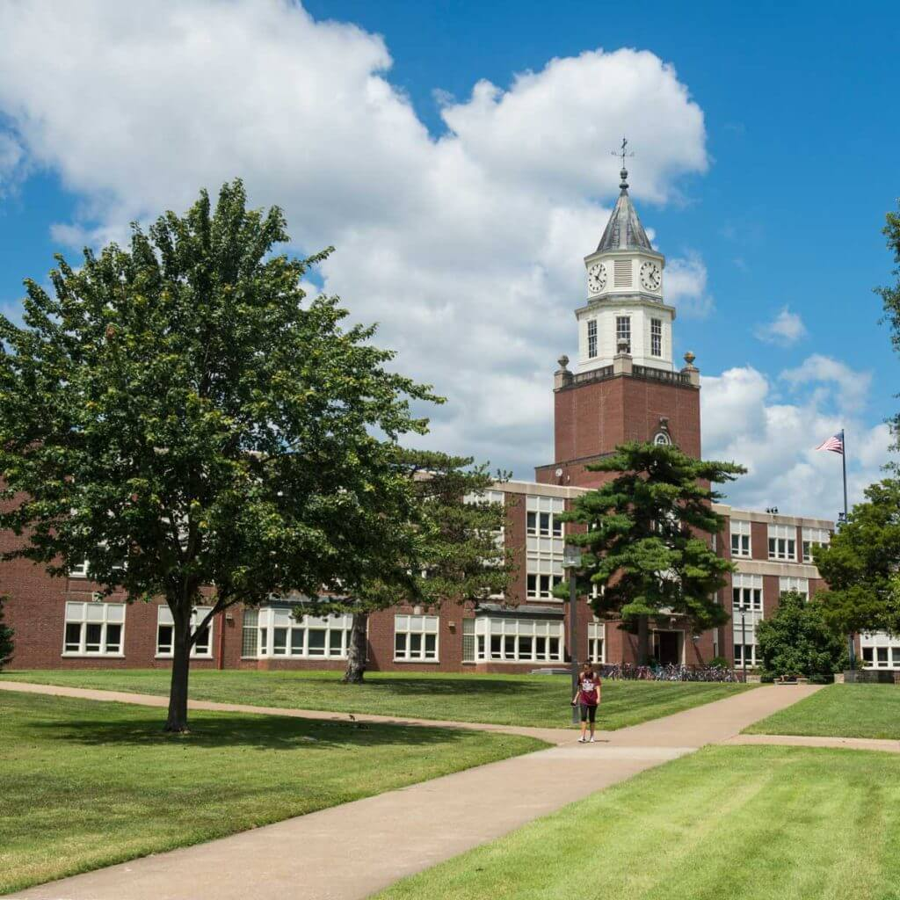**

**Sooo many super interesting courses**

|  |
| --- |
| ***Detailed Class Information*** |
| **Beginning Sign Language - 26340 - FL 120B - 001** |
| **Associated Term:**Spring 2019  **Levels:**Undergraduate   Carbondale Campus Campus  Lecture Schedule Type  Lecture Instructional Method  3.000 Credits |

|  |
| --- |
| ***Detailed Class Information*** |
| **Strength Training - 21101 - KIN 104D - 001** |
| **Associated Term:**Spring 2019  **Levels:**Undergraduate   Carbondale Campus Campus  Lecture Schedule Type  Lecture Instructional Method  2.000 Credits |

|  |
| --- |
| ***Detailed Class Information*** |
| **Musculoskeletal Anatomy - 24753 - KIN 300 - 002** |
| **Associated Term:**Spring 2019  **Levels:**Undergraduate   Carbondale Campus Campus  Lecture Schedule Type  Lecture Instructional Method  3.000 Credits |

|  |
| --- |
| ***Detailed Class Information*** |
| **Motor Behavior - 21140 - KIN 313 - 001** |
| **Associated Term:**Spring 2019  **Levels:**Undergraduate   Carbondale Campus Campus  Lecture Schedule Type  Lecture Instructional Method  3.000 Credits |

|  |
| --- |
| **Biomechanics Human Movement - 21145 - KIN 321 - 002** |
| **Associated Term:**Spring 2019  **Levels:**Undergraduate   Carbondale Campus Campus  Lecture Schedule Type  Lecture Instructional Method  3.000 Credits |

|  |
| --- |
| **Invented Languages - 27536 - LING 302 - 001** |
| **Associated Term:**Spring 2019  **Levels:**Undergraduate   Carbondale Campus Campus  Lecture Schedule Type  Lecture Instructional Method  3.000 Credits |

|  |
| --- |
| **Language, Gender, and Power - 22378 - LING 320I - 001** |
| **Associated Term:**Spring 2019  **Levels:**Undergraduate   Carbondale Campus Campus  Lecture Schedule Type  Lecture Instructional Method  3.000 Credits |

|  |
| --- |
| **Assess ESL/Bilingual Students - 24845 - LING 472 - 001** |
| **Associated Term:**Spring 2019  **Levels:**Graduate, Doctorate, Graduate, Masters, Undergraduate   Carbondale Campus Campus  Lecture Schedule Type  Lecture Instructional Method  3.000 Credits |

|  |
| --- |
| **Basic Anatomy w/ Lab - 23907 - PHSL 301 - 007** |
| **Associated Term:**Spring 2019  **Levels:**Undergraduate   Carbondale Campus Campus  Lecture Schedule Type  Lecture Instructional Method  4.000 Credits |

|  |
| --- |
| **Med/Psycho-Social:Disability - 24999 - REHB 513 - 001** |
| **Associated Term:**Spring 2019  **Levels:**Graduate, Doctorate, Graduate, Masters, Master of Laws, Undergraduate, Professional, Law   Carbondale Campus Campus  Lecture Schedule Type  Lecture Instructional Method  1.000 TO 4.000 Credits |

|  |
| --- |
| ***Detailed Class Information*** |
| **Psychopharmacology - 23223 - PSYC 415 - 001** |
| **Associated Term:**Spring 2019  **Levels:**Graduate, Doctorate, Graduate, Masters, Undergraduate |

|  |
| --- |
| ***Detailed Class Information*** |
| **Bilingualism - 25640 - PSYC 443 - 001** |
| **Associated Term:**Spring 2019  **Levels:**Graduate, Doctorate, Graduate, Masters, Undergraduate |

|  |
| --- |
| ***Detailed Class Information*** |
| **Psychopharmacology & Behavior - 23224 - PSYC 518 - 001** |
| **Associated Term:**Spring 2019  **Levels:**Graduate, Doctorate, Graduate, Masters, Master of Laws, Undergraduate, Professional, Law   Carbondale Campus Campus  Lecture Schedule Type  Lecture Instructional Method  4.000 Credits |

|  |
| --- |
| **Psychology of Crime - 26277 - PSYC 237 - 953** |
| **Associated Term:**Spring 2019  **Levels:**Undergraduate   Web-Based Distance Learning Campus  Lecture Schedule Type  Online Instructional Method  3.000 Credits |

|  |
| --- |
| ***Detailed Class Information*** |
| **Effects Recreational Drugs - 24187 - PSYC 222 - 001** |
| **Associated Term:**Spring 2019  **Levels:**Undergraduate   Carbondale Campus Campus  Lecture Schedule Type  Lecture Instructional Method  3.000 Credits |

|  |
| --- |
| **Abnormal Psychology - 22135 - PSYC 331 - 001** |
| **Associated Term:**Spring 2019  **Levels:**Undergraduate   Carbondale Campus Campus  Lecture Schedule Type  Lecture Instructional Method  3.000 Credits |

**West Virginia University**

All areas for which students are academically qualified.

Min = 12 credits (undergraduate) & 9 credits (grad)  
Max = 18 credits (undergraduate)

|  |
| --- |
| ***Sections Found*** |
| [**Human Anatomy Laboratory - 12296 - NBAN 206 - 7D2**](https://star.wvu.edu/pls/starprod/bwckschd.p_disp_detail_sched?term_in=201901&crn_in=12296) |
| **Associated Term:**Spring 2019  **Registration Dates:**Oct 01, 2018 to Jan 11, 2019  **Levels:**Graduate, Professional, Undergraduate  **Attributes:**St Auth Reciprocity Agreement   WVU Campus Course Campus  Web Based Schedule Type  Web Off Campus Instructional Method  1.000 Credits |
| **Sections Found** |
| [**Neuroscience Journal Club - 14635 - NBAN 760 - 001**](https://star.wvu.edu/pls/starprod/bwckschd.p_disp_detail_sched?term_in=201901&crn_in=14635) |
| **Associated Term: Spring 2019  Registration Dates: Oct 01, 2018 to Jan 11, 2019  Levels: Graduate, Professional   WVU Campus Course Campus  Lecture Schedule Type  1.000 Credits** [**View Catalog Entry**](https://star.wvu.edu/pls/starprod/bwckctlg.p_display_courses?term_in=201901&one_subj=NBAN&sel_crse_strt=760&sel_crse_end=760&sel_subj=&sel_levl=&sel_schd=&sel_coll=&sel_divs=&sel_dept=&sel_attr=)  **Reviewing recent neuroscience papers** |
| **Sections Found** |
| [**Intro to Abnormal Psychology - 18872 - PSYC 281 - 003**](https://star.wvu.edu/pls/starprod/bwckschd.p_disp_detail_sched?term_in=201901&crn_in=18872) |
| **Associated Term: Spring 2019  Registration Dates: Oct 01, 2018 to Jan 11, 2019  Levels: Graduate, Professional, Undergraduate, PSC Undergraduate, WVUIT Undergraduate  Attributes: GEF Area 7, GEC Objective 4, GEC Objective 6   WVU Campus Course Campus  Lecture Schedule Type  3.000 Credits** |
| [**Legal Issues-Clinical Psychlgy - 11421 - PSYC 605 - 001**](https://star.wvu.edu/pls/starprod/bwckschd.p_disp_detail_sched?term_in=201901&crn_in=11421) |
| **Associated Term: Spring 2019  Registration Dates: Oct 01, 2018 to Mar 05, 2019  Levels: Graduate, Professional   WVU Campus Course Campus  Lecture Schedule Type  1.000 Credits** |
| **Sections Found** |
| [**Behavioral Neuroscience Method - 17637 - PSYC 650 - 001**](https://star.wvu.edu/pls/starprod/bwckschd.p_disp_detail_sched?term_in=201901&crn_in=17637) |
| **Associated Term: Spring 2019  Registration Dates: Oct 01, 2018 to Jan 11, 2019  Levels: Graduate, Professional   WVU Campus Course Campus  Lecture Schedule Type  3.000 Credits** |
| **Sections Found** |
| [**Hormones and Behavior - 17585 - PSYC 728 - 001**](https://star.wvu.edu/pls/starprod/bwckschd.p_disp_detail_sched?term_in=201901&crn_in=17585) |
| **Associated Term: Spring 2019  Registration Dates: Oct 01, 2018 to Jan 11, 2019  Levels: Graduate, Professional   WVU Campus Course Campus  Lecture Schedule Type  3.000 Credits** |
| **Sections Found** |
| [**Disability Across the Lifespan - 11383 - REHB 612 - 7D1**](https://star.wvu.edu/pls/starprod/bwckschd.p_disp_detail_sched?term_in=201901&crn_in=11383) |
| **Associated Term: Spring 2019  Registration Dates: Oct 01, 2018 to Jan 11, 2019  Levels: Graduate, Professional   WVU Campus Course Campus  Web Based Schedule Type  Web Off Campus Instructional Method  3.000 Credits** |
| **Sections Found** |
| [**Introduction to Human Anatomy - 11387 - NBAN 205 - 7D1**](https://star.wvu.edu/pls/starprod/bwckschd.p_disp_detail_sched?term_in=201901&crn_in=11387) |
| **Associated Term: Spring 2019  Registration Dates: Oct 01, 2018 to Jan 11, 2019  Levels: Graduate, Professional, Undergraduate  Attributes: St Auth Reciprocity Agreement   WVU Campus Course Campus  Web Based Schedule Type  Web Off Campus I** |
| **Sections Found** |
| [**Intro:Native American Studies - 14005 - NAS 200 - 001**](https://star.wvu.edu/pls/starprod/bwckschd.p_disp_detail_sched?term_in=201901&crn_in=14005) |
| **Associated Term: Spring 2019  Registration Dates: Oct 01, 2018 to Jan 11, 2019  Levels: Graduate, Professional, Undergraduate, PSC Undergraduate  Attributes: GEF Area 7, GEC Objective 4, GEC Objective 9   WVU Campus Course Campus  Lecture Schedule Type  3.000 Credits** |
| **Sections Found** |
|  |
| [**Theory of Aquatic Therapy - 11930 - EXPH 450 - 001**](https://star.wvu.edu/pls/starprod/bwckschd.p_disp_detail_sched?term_in=201901&crn_in=11930) |
| **\*This course requires a certification fee of $85.  Associated Term: Spring 2019  Registration Dates: Oct 01, 2018 to Jan 11, 2019  Levels: Graduate, Professional, Undergraduate, PSC Undergraduate   WVU Campus Course Campus  Lecture Schedule Type  4.000 Credits** |
|  |
| **Sections Found** |
| [**Anatomy for Exercise Physiol - 17397 - EXPH 440 - 001**](https://star.wvu.edu/pls/starprod/bwckschd.p_disp_detail_sched?term_in=201901&crn_in=17397) |
| **Associated Term: Spring 2019  Registration Dates: Oct 01, 2018 to Jan 11, 2019  Levels: Graduate, Professional, Undergraduate   WVU Campus Course Campus  Lecture Schedule Type  3.000 Credits** |
| **Sections Found** |
| [**Exercise Physiology 1 - 10786 - EXPH 365 - 001**](https://star.wvu.edu/pls/starprod/bwckschd.p_disp_detail_sched?term_in=201901&crn_in=10786) |
| **This section is for CPASS majors only. EXPH majors only upon departmental approval.  Associated Term: Spring 2019  Registration Dates: Oct 01, 2018 to Jan 11, 2019  Levels: Graduate, Professional, Undergraduate, WVUIT Undergraduate   WVU Campus Course Campus  Lecture Schedule Type  3.000 Credits** |
| **Sections Found** |
| [**Artificial Intelligence - 11613 - CS 472 - 001**](https://star.wvu.edu/pls/starprod/bwckschd.p_disp_detail_sched?term_in=201901&crn_in=11613) |
| **Associated Term: Spring 2019  Registration Dates: Oct 01, 2018 to Jan 11, 2019  Levels: Graduate, Professional, Undergraduate, WVUIT Undergraduate   WVU Campus Course Campus  Lecture Schedule Type  3.000 Credits** |
| **Sections Found** |
| [**Computer Languages - 18825 - CS 365 - T01**](https://star.wvu.edu/pls/starprod/bwckschd.p_disp_detail_sched?term_in=201901&crn_in=18825) |
| **Associated Term: Spring 2019  Registration Dates: Oct 01, 2018 to Mar 26, 2019  Levels: WVUIT Undergraduate   WVUIT Campus Course Campus  Lecture Schedule Type  1.000 Credits** |
| **Sections Found** |
| [**SPTP: Human Anatomy - 18787 - BIOL 393B - 004**](https://star.wvu.edu/pls/starprod/bwckschd.p_disp_detail_sched?term_in=201901&crn_in=18787) |
| **Associated Term: Spring 2019  Registration Dates: Oct 01, 2018 to Jan 11, 2019  Levels: Graduate, Professional, Undergraduate   WVU Campus Course Campus  Lecture Schedule Type  4.000 Credits** |
| **Sections Found** |
| [**Human Anatomy and Physiology 1 - 12815 - BIOL 230 - P01**](https://star.wvu.edu/pls/starprod/bwckschd.p_disp_detail_sched?term_in=201901&crn_in=12815) |
| **Students must register for both lecture and laboratory.  Associated Term: Spring 2019  Registration Dates: Oct 01, 2018 to Jan 11, 2019  Levels: PSC Undergraduate, WVUIT Undergraduate   PSC Campus Course Campus  Lecture Schedule Type  4.000 Credits** |
| **Sections Found** |
| [**Drugs and the Body - 16270 - BIOL 108 - P01**](https://star.wvu.edu/pls/starprod/bwckschd.p_disp_detail_sched?term_in=201901&crn_in=16270) |
| **Associated Term: Spring 2019  Registration Dates: Oct 01, 2018 to Jan 11, 2019  Levels: Graduate, Professional, Undergraduate, PSC Undergraduate  Attributes: GEF Area 2A   PSC Campus Course Campus  Lecture Schedule Type  3.000 Credits** |

**University of Nebraska at Omaha**

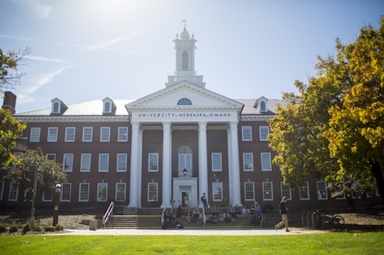**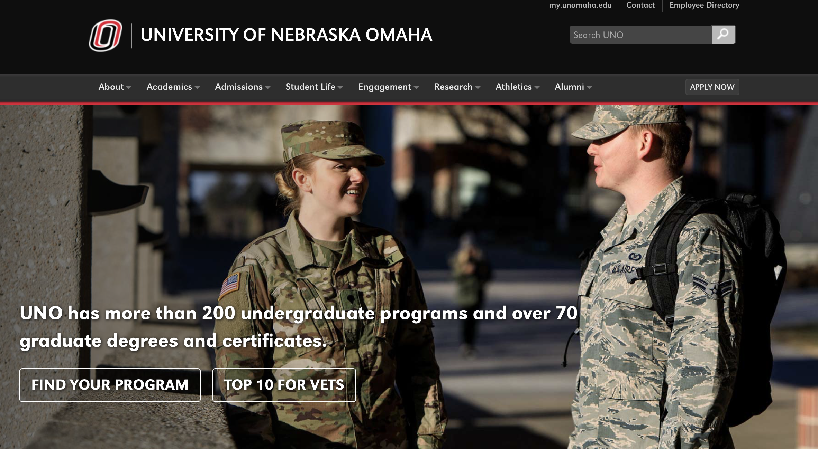**

**irritating???**

Architecture, Psychology (graduate), and Interior Design. Education courses are limited.

12-15 credits, undergraduate

Students accepted to our program will receive assistance with course registration through the Education Abroad Office after admission and prior to arrival.

Spring 2018: January 8 - May 3

Yes, all students are required to live in on-campus, apartment style housing and receive application information via Mavlink after admissions

Health care(approx.) $950 per term

PSYC 4560

FORENSIC PSYCHOLOGY

The roles and functions of forensic psychologists, as participants in the legal system, are studied, with special emphasis on the relevance of theories and principles from social psychology. Psychological concepts, theories, data, research methods and applications to varied substantive topics are examined (e.g., forensic careers, police psychology, violence, criminal profiling, sociopathy and psychopathy, risk assessment, expert testimony, and corrections).

Prereq: PSYC 1010 or SOC 1010 and PSYC 3450 or SOC 3450.

PSYC 4590

PSYC4590

PSYCH OF EXCEPTIONAL CHILDREN

A study of exceptional children and adolescents with sensory or motor impairments, intellectual retardations or superiorities, talented or gifted abilities, language or speech discrepancies, emotional or behavioral maladjustments, social or cultural differences, or major specific learning disabilities.

Prereq: PSYC 1010 and junior/senior

PSYC 8116

PSYC8116

POLITICAL PSYCHOLOGY

This course introduces students to the role of human thought, emotion, and behavior in politics through examination of the psychological factors that motivate political elites and the mass public. (Cross-listed with PSCI 4110, PSCI 8116, PSYC 4110)

Prereq: PSCI 1100 is recommended.

PSYC8446

PSYC 8446

ABNORMAL PSYCHOLOGY

A course designed to examine the aberrant behavior of individuals. Symptoms, dynamics, therapy and prognosis of syndromes are considered. (Cross-listed with PSYC 4440)

Prereq: PSYC 1010. Not open to non-degree graduate students.

PSYC 8476

MENTAL HEALTH AND AGING

The goal of this course is to survey the mental health needs of older adults. Consideration is given to identifying both positive mental health and pathological conditions. Treatment interventions effective with older adults and their families also are discussed. (Cross-listed with PSYC 4470, GERO 4470, GERO 8476)

Prereq: Junior or senior.

PSYC 3410

CLINICAL PSYCHOLOGY

A broad survey of problems and practices in the diagnosis and treatment of emotional and behavioral disorders.

Prereq: PSYC 1010.

BIOL 3500

BIOL3500

BIOLOGICAL PRINCIPLES OF AGING

The Biological Bases of Aging Course provides a survey of the primary topics in the biology of aging field for undergraduate students. This a required course for the Gerontology major. By the end of the course, students will understand major theories, biological methods, and seminal research studies in the biology of aging field. Furthermore, students will learn how to critically analyze and interpret primary research about biological aging. This course provides preparation for students considering graduate school in gerontology or biology, geriatric nursing and social work, geriatric medicine, neuroscience, psychology, and exercise science. (Cross-listed with GERO 3500, NEUR 3500)

Prereq: Sophomore/Junior/Senior Standing. Not open to non-degree graduate students.

BIOL4890

BIOL 4890

GENES, BRAIN, AND BEHAVIOR

This course will evaluate the complex interaction between an organism's genome and neural activity pattern in the nervous system as related to behavior. In this course students will explore how changes in gene expression (allelic variants, epigenetics, differential regulation) and gene networks within neural tissue can reciprocally influence behaviors such as communication, foraging, reproduction, and cognition. (Cross-listed with NEUR 4890, BIOL 8896, PSYC 8896)

Prereq: NEUR 1500 and BIOL 2140 or by permission of instructor. Not open to non-degree graduate students.

HPER2000

HPER 2000

MEDICAL TERMINOLOGY

This course provides students the foundation for understanding medical language and terminology used in health-related careers. Students will gain an understanding of the basic elements used to build and analyze medical terms used to describe the human body. Utilizing the body systems approach, students will learn correct pronunciation, definitions, and spelling used to describe the human body, pathological processes, procedures,as well as conditions and diseases that affect it.

CRCJ 3350

CRCJ 3350

CRIMINOLOGY

General survey of the nature and causes of crime and the effort of the criminal justice system to predict, prevent, modify and correct this behavior.

Prereq: Upper-division CRCJ major; CRCJ minor; CRCJ 1010 and jr/sr standing; or instructor permission.

NAMS 1100

NAMS1100

INTRO NATIVE AMERICAN STUDIES

This course will introduce the diverse cultures of Native Americans. Using both historical and contemporary experiences, students will learn about the cultural, historical, social, economic and/or political factors that have shaped Native experience in North America. Students will also acquire new insights about American history and culture by looking through the lens of contemporary native cultures, nations and individuals.

**University of Western Ontario**

**Courses in the following departments are sometimes limited, and not always available to exchange students:**

* Management and Organizational Studies
* Economics
* Education – not available to any exchange student; Western’s program is one year only.
* Kinesiology
* Psychology
* Political Science – upper year courses have limited enrollment
* Richard Ivey School of Business - students must be attending a University that has a specific agreement with the Richard Ivey School of Business.
* Medicine and Dentistry – both programs are closed to exchange students

**If not possible to take Psychology classes not worthwile**

**University of Victoria**

**Mainly business courses**

**University of Ottawa**

does not cover Medicine, Psychology, Education, and Management.

Only cool class is “Bilingualism” , Neuroscience and stuff seems to be part of Molecular Medicine so I guess I can’t take them, also no Psychology classes

**University of Wisconsin-Madison**

The agreement does not cover the university’s professional schools (Medicine, Veterinary Medicine, Pharmacy, Nursing, Law, Education etc.)

Probably 5 courses

Finding courses through the course finder is a fucking pain in the ass

|  |  |  |  |
| --- | --- | --- | --- |
| NTP | 675 | Special Topics > Topic: Molecular Mechanisms of Brain Damage |  |

|  |  |  |  |
| --- | --- | --- | --- |
| NTP | 660 | Neuroscience & Public Policy |  |

|  |  |  |  |  |
| --- | --- | --- | --- | --- |
| NEURODPT | 699 | NEURODPT 699 |  | Consent of instructor |

|  |  |  |
| --- | --- | --- |
| PSYCH | 405 | Abnormal Psychology |

|  |  |  |
| --- | --- | --- |
| PSYCH | 601 | Current Topics - Psychology > Developing babies, building robots > Epigenetics and the Brain > Fundamentals of Clinical Psychology > Legal Psychology: Criminal & Civil Issues > Nature v. Nurture Mental Illness > To Be Announced > Topic: Media & Mental Illness > Topic: Mood Disorders > Topic: Psychology of Juvenile Delinquency |

|  |  |  |  |  |
| --- | --- | --- | --- | --- |
| PSYCH | 526 | Criminal Mind:Forensics/Scienc | \_\_SIC | PSYCH 403 (507 prior to spring 2018), PSYCH 405 (509 prior to fall 2017), or |

|  |  |  |
| --- | --- | --- |
| PSYCH | 611 | Systems Neuroscience |

**North Park University**

**Chicago**

**Gut feeling is a no**

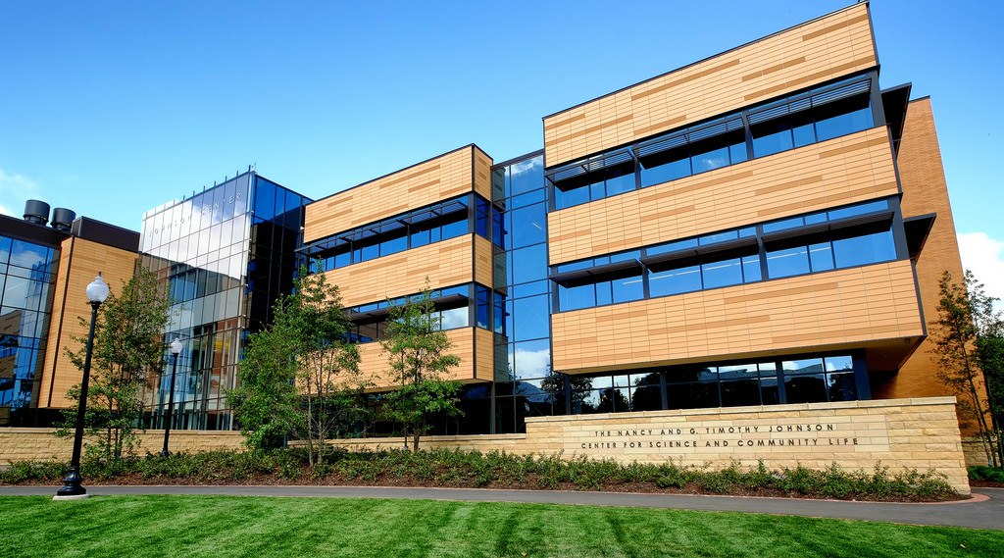

Typically, rst-year rst-semester students may not enroll for more than 16 credit hours.

1250 Introduction to Human Anatomy (4 sh) GE

Includes structure and organization of human organ systems emphasizing skeletal, muscular, digestive, circulatory, respira- tory, nervous, and urogenital systems. Lab included with cadaver demonstrations. It is recommened that the student complete one year of high school laboratory science.

3170 Native Wild owers, Trees and Shrubs of the Great Lakes Region (4 sh)

A survey of the native spring wild owers, common trees and shrubs of the Great Lakes Region. Particular attention will be given to the use of taxonomic keys and eld guides in eld identi cation as well as information on the general ecology of each species. Weekly eld trips to local and regional forest preserves, natural areas and a weekend eld trip to southern Illinois will be required. Lab included. Prerequisite: BIOL 1280 or BIOL 2280.

3160 Exercise Physiology (4 sh)

Study of human anatomy and physiology with emphasis on neuromuscular and cardiorespiratory systems, stressing the e ects of exercise on those systems. Lab included. Cross-listed with EXS 3160. Prerequisite: BIOL 1250.

2280 Introduction to Botany (4 sh) GE

Survey of the plant kingdom and related organisms from algae to owering plants. Identi cation of campus Vascular plants. Basic life processes including photosynthesis, plant develop- ment, reproductive cycles, owering and fruiting responses, and the ecological importance and conservation of plants.

A WR emphasis with research term paper, experimental lab write-up and career development components. Lab included. Prerequisite: BIOL 1250 or 1260.

1280 Introduction to Botany (2 sh)

Survey of the plant kingdom from algae to the owering plants. Basic life processes including photo responses, cellular and plant systems development, reproductive cycles, owering and fruiting responses. Environmental succession and plant climax communities. Lab included. Prerequisite: BIOL 1250 or 1260.

3000 Introduction to Con ict Transformation (4 sh)

This is an introduction to the practice and philosophy of nonviolent con ict transformation. The course assumes that con ict is a normal part of our daily lives, with both construc- tive and destructive potential. Students will learn introductory skills in con ict analysis and con ict transformation, including theories, methods, and practices for con ict transformation and peacebuilding; examine their own approaches to con ict; meet North Park faculty and others working in the broad eld of con ict transformation; and develop a deeper understanding of the role of the arts and spirituality for con ict transforma- tion, including the interplay of justice, truth, forgiveness, and peacebuilding.

3200 Mediation (4 sh)

This course provides students with both theoretical and practical knowledge of mediation. Through case studies and other readings, experiential exercises, guest presentations, and lectures, students will be introduced to the practice of mediation in interpersonal, intercultural, and organizational contexts. Students will also examine issues of ethical relevance to the practice of mediation. Upon completion of this course, students will have the skills to conduct mediations. However, this course is not designed to certify participants for special- ized mediation services such as court-mandated mediation or arbitration.

3300 Performance and Social Change (4 sh)

The goals of this course are: to develop skills, competencies, and points of view needed to create ethnographic performanc- es-through engagement with theory, research, eld work, empa- thy, advocacy for social justice, and writing for performance; to learn several models for connecting performance and social change; and to develop and present a performance for social

North Park University | Academic Catalog 2018–2019

80

change. Recent research topics have included immigration experiences and peacemakers in Chicago.

1600 First Aid/CPR (2 sh)

Study of immediate care of the injured or ill. Based on American Red Cross standards. Certi cation in First Aid, CPR, and AED available.

1000 Personal Health (2 sh) GE

A study of physical and psychological well-being, including exercise and nutrition.

4200 Psychiatric/Mental Health Nursing (4 sh)

Integrates knowledge of human development, behavior, and psychological theory; places emphasis on increasing self-aware- ness and therapeutic use of self and milieu. With assistance and use of collaborative skills, students develop decision-making skills in the psychiatric-mental health care delivery system in a way that communicates respect and understanding

3600 Abnormal Psychology (4 sh)

Studies psychological disorders, etiologies, assessment, and interventions. This includes the history of abnormal psychol- ogy; theory and research; and biological, psychological, and social approaches to treatment. Prerequisite: PSYC 2100.

2100 Research Methods in Psychology (4 sh) GE

Introduces the methods and statistics used in the study of psychology, including surveys, correlational studies, and experiments Special attention to the unique requirements of human subjects. Prerequisite: PSYC 1000, STAT 1490.

1000 Introduction to Psychology (4 sh)

An introduction to the methodology and the major content areas of psychology.

1200 Stress and Health (2 sh) GE

Introduces the concepts of stress and health, including physical and psychological well-being, nutrition, and exercise.

2500 Health and Behavior (4 sh) GE

Study of the dimensions of health and selected health topics with emphasis on how one’s behavior a ects health. Prerequisite: EXS 1000 or PSYC 1200.